
FlashForge Corporation

FlashForge Inventor 3D Printer User Guide

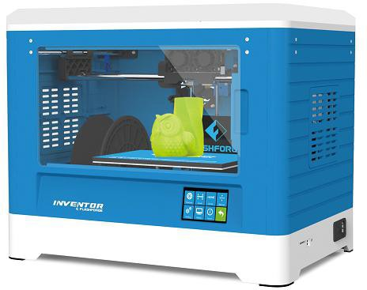

Content
Content 2
Introduction 4
Notice 5
Chapter 1: 3D Printing Technology 8
  - Process 8
Chapter 2 . About Inventor 10
  - About Your Inventor 10
    - Main view 10
Chapter 3. Unpacking 14
Chapter 4 . Hardware Assembly 16
  - Mounting the Extruder Set 17
  - Plugging in Power Cable&USB Cable 20
  - Loading and Unloading Filament 20
Chapter 5: Build Plate Leveling 24
Chapter 6: About Software 26
  - Software Installation 27
  - Exploring FlashPrint 28
Chapter 7: Basic Printing 53
  - Single-Extrusion and Dual-Extrusion Print 53
  - Methods of printing 59
  - Camera Setting 63
  - Resume Print 67
Chapter 8: Supports and Service 69

Preface
Note: Each device must be tested before leaving factory. If there are some residues in extruder or some tiny scratches on the build tape, it is normal and won’t affect the printing quality.

On the completion of this User Guide, thanks all FlashForge engineers and the FlashForge 3D printer users for their unremitting efforts and sincere assistance.

The FlashForge Inventor User Guide is designed for the Inventor users to start their printing journey with FlashForge Inventor. Even if you are familiar with earlier FlashForge machines or 3D printing technology, we still recommend that you read through this guide, as there is lots of important information about the Inventor for you to get a better 3D experience.

For a better and more successful printing experience, you can refer to the following materials:

Quick Start Guide
Users will find the Quick Start Guide together with the printer accessories. The Quick Start Guide will help you start your print journey as soon as possible.
- Official FlashForge Website: http://www.FlashForge.com
The official FlashForge website contains the up-to-date information concerning FlashForge software, firmware, device maintenance and so on. Users are also able to get the contact information from there.

Notes：

Introduction

·Please read FlashForge Inventor 3D Printer User Guide carefully before use.
·The User Guide is written based on Windows 7 OS.
·The version of the FlashPrint is latest.
The FlashForge Inventor 3D Printer User Guide contains the information needed for you to set up and use this device.

This User Guide including the following parts: Preface, Introduction and After-sale service.

The Preface section includes resource acquisition channel, the overall framework of the manual, and the problems that should be paid attention to while printing.

The introduction section contains the overview of 3D printing technology, equipment introduction, unpacking and installation of equipment, software installation and usage.

After-sale section contains the user how to get the support and help.

Safety Notice

Notice

! Notices: Read all the instructions in the manual and familiarize yourself with the FlashForge Inventor User Guide before set-up and use. Failure to comply with the warning and instructions may result in individual injury, fire, equipment damage or property damage.

PLEASE STRICTLY FOLLOW ALL THE SAFETY WARNINGS AND NOTICE BELOW ALL THE TIME.

· Work Environment Safety
① Keep your work place tidy.
② Do not operate Inventor in the presence of flammable liquids, gases or dust.
③ Keep Inventor out of reach of children and untrained people.

· Electrical Safety
① Always use the Inventor with a properly grounded outlet. Do not modify Inventor plug.
② Do not use Inventor in damp or wet locations. Do not expose Inventor to burning sun.
③In case of device damage, please use the power supply provided by FlashForge.
④ Avoid using the device during a thunderstorm.
⑤ In case of uncertain accident, please unplug the device if you do not use it for long.

·Personal Safety
① Do not touch the nozzle and build plate during printing.
② Do not touch the nozzle after finishing printing.

③ Dress properly. Do not wear loose clothing or jewelry. Keep your hair, clothing and gloves away from moving parts.
④ Do not operate the device while you are tired or under the influence of drugs, alcohol or medication.

· Cautions
① Do not leave the device unattended for long.
② Do not make any modifications to the device.
③ Lower the build plate before loading/unloading filament. (The distance between the nozzle and build plate should be kept for at least 50mm)
④ Operate the device in a well-ventilated environment.
⑤ Never use the device for illegal activities.
⑥ Never use the device to make any food storage vessels.
⑦ Never use the device to make any electrical appliance.
⑧ Never put the model into your mouth.
⑨ Do not remove the models with force.

- Environment Requirements Temperature: RT 15-30℃ Moisture: 20%-70%

Place Requirements
The device must be placed in a dry and ventilated environment. The distances of the left, right and back side space should be at least 20cm, and the distance of the front side space should be at least 35cm.

Filament Requirements
Do not abuse the filament. Please make sure you use the FlashForge filament or the filament from the brands accepted by FlashForge.

Filament Storage
All polymers degrade with time. Do not unpack filament until necessary. Filament should be stored at clean and in dry conditions.

Legal Notice
All the information in this document is subject to any amendment or change without the official authorization from FlashForge.

FLASHFORGE CORPORATION MAKES NO WARRANTY OF ANY KIND WITH REGARD TO THIS DOCUMENT, INCLUDING, BUT NOT LIMITED TO, THE IMPLIED WARRATIES OF MERCHANTABILITY AND FITNESS FOR A PARTICULAR PURPOSE.

FlashForge shall not be liable for errors contained herein for incidental consequential damages in connection with furnishing, performance or use of this material

This document contains proprietary information protected by copyright.
Copyright © 2017 FlashForge Corp. All Rights Reserved

Chapter 1: 3D Printing Technology

3D printing is transforming three-dimensional models into physical objects that you can hold and touch. It is also called additive manufacturing because the 3D model is created by “adding” layers upon layers of material until the object is fully formed.

Fused Filament Fabrication (FFF) is the most common method of 3D printing. It is also the method that the Inventor uses. It works by melting plastic material called filament onto a print surface in high temperature. The filament solidifies after it cools down, which happens instantaneously after it is extruded from the nozzle. 3D objects are formed with the filament laying down multiple layers.

Process

3D printing involves three steps:
- Make or download a 3D model
- Slice and export the 3D model
- Build the 3D model

    - Make a 3D Model

Currently, there are three ways to creating a 3D model.
·Designing From Scratch You can use free CAD (computer-aided design) software such as 3DTADA, AutoCAD, SolidWorks, Pro-E, and our own software Happy 3D to design your own 3D model.
·3D Scanners An alternative method to creating a 3D model is to scan an object. 3D scanners work by digitizing a physical object, collecting its geometric data, and saving it to a file on your PC. There are also apps that can turn a mobile device into a 3D

scanner.
·From the Cloud The most popular way of obtaining a 3D model is to download it from websites that allow users to upload 3D models that they designed.
E.g. www. thingiverse.com

    - Slice and Export the 3D Model

Slice software is the software that prepares 3D models for printing and turns them into instructions for the 3D printers. FlashPrint is the slicing software used for the FlashForge Inventor.

Using FlashPrint, you can turn .stl files to be .g or .gx files for printing. Then the files can be transferred to your Inventor via USB cable, SD card or Wi-Fi.

    - Build the 3D Model
Once the output file has been transferred to your Inventor, it will start to turn the 3D model into a physical object by laying down layers of filament.

Chapter 2 . About Inventor

About Your Inventor

    - Main view: 1. Camera

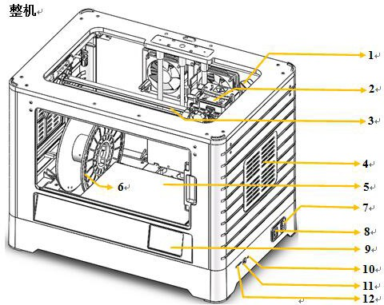
Whole Machine

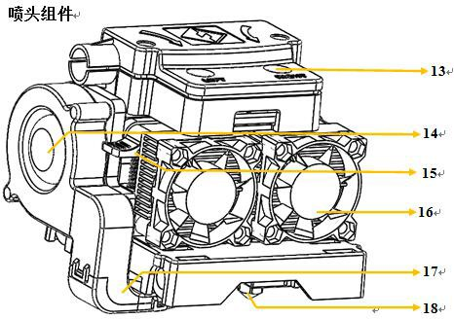
Extruder Component
- Extruder
- Timing belt
- Panel
- Build plate
- Filament
- Power input
- Power switch
- Touch screen
- Reset button
- USB cable input
- SD card slot
- Filament intake
- Turbofan
- Spring presser
- Cooling fan
- Turbofan baffle
- Nozzle

    - Accessory Box

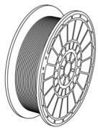
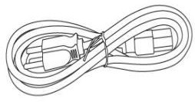
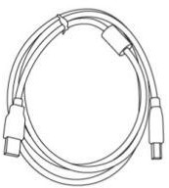
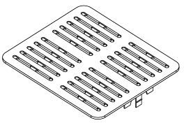
Filament*2 Power Cable USB Cable Panel*2

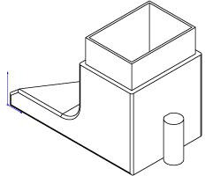
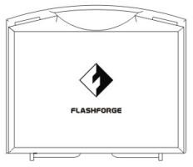

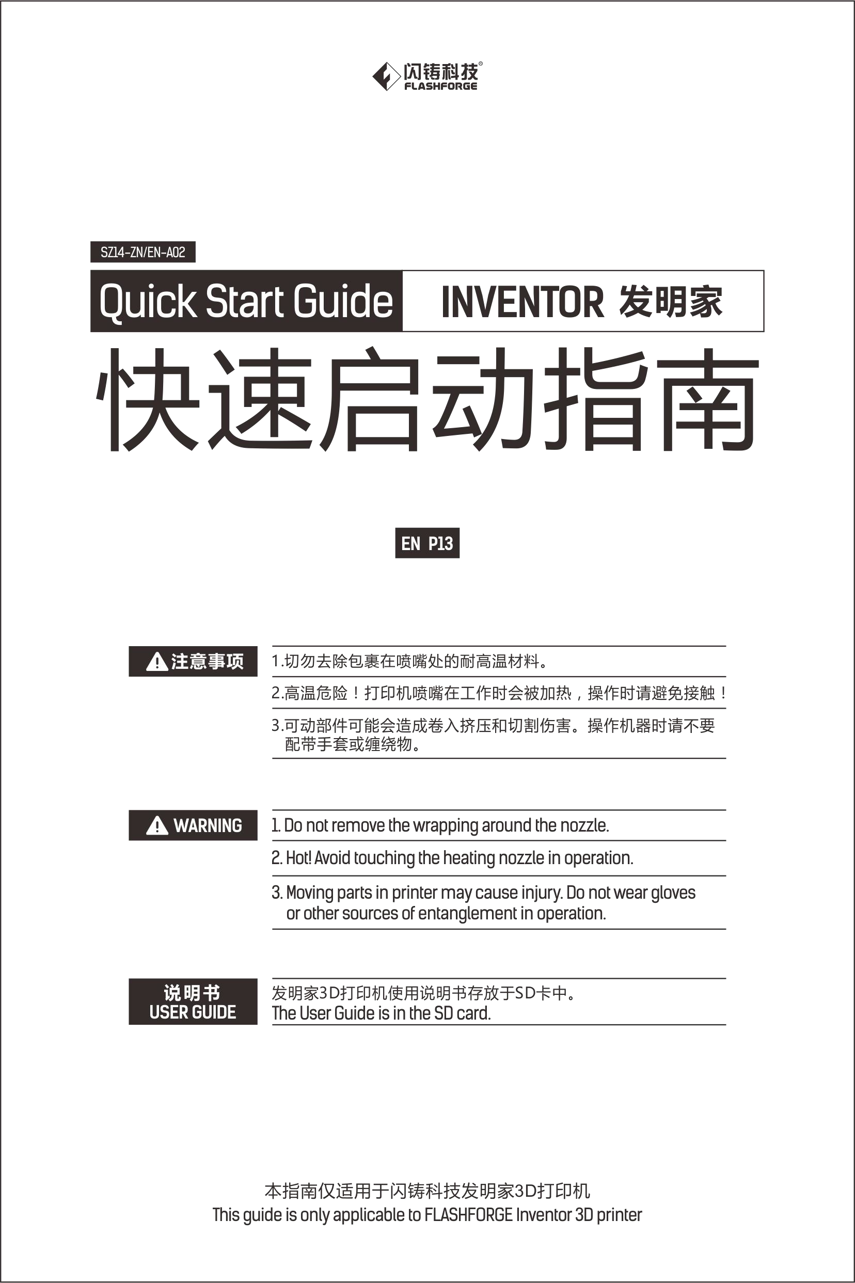
Turbofan Baffle Toolbox Build Tape Quick Start Guide
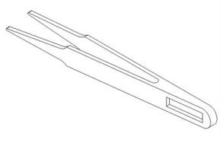
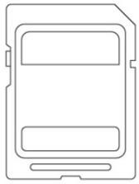
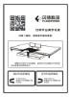
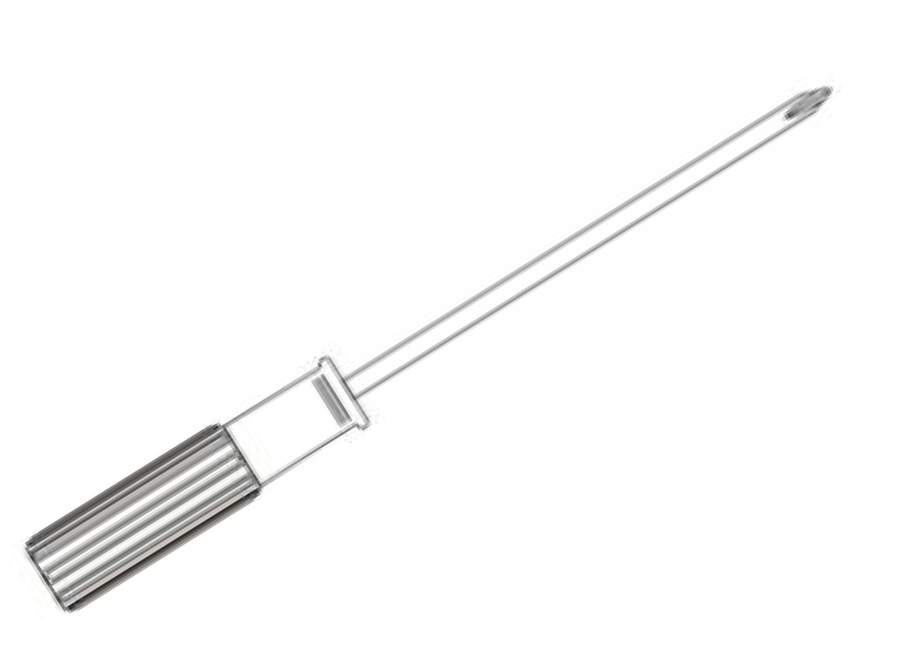
Tweezers SD Card Leveling Card Screwdriver
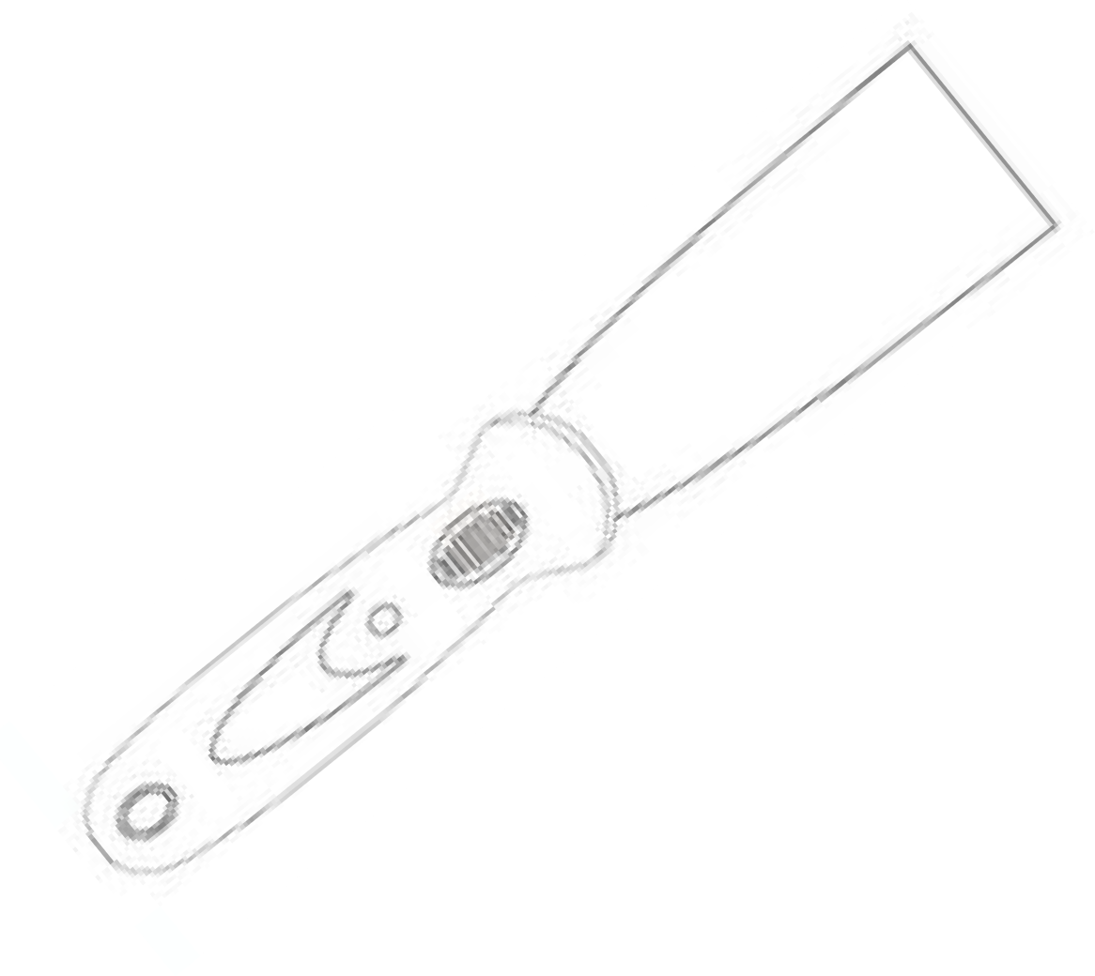
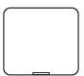
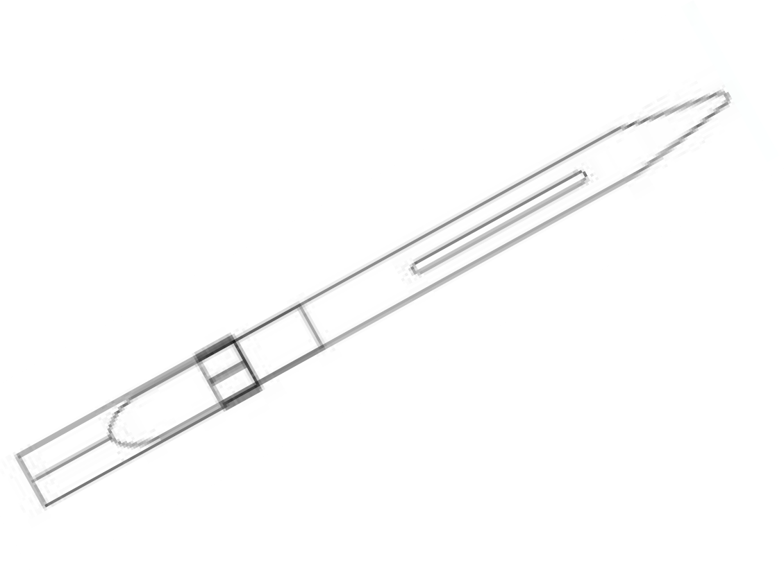
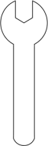
Scraper Screw Box Carving Knife Stamping Wrench

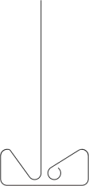

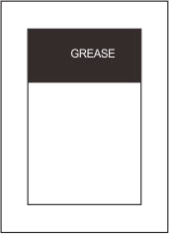
Unclogging Pin Tool Allen Wrench Grease

    - Terms

Build Plate | The surface on which the Inventor builds an object.
Build Tape | The blue tape that covers Inventor’s build plate so that the object can stick to the build plate well.
Build Volume | The three dimensional amount of space that an object will use once it is completed. The largest build volume of Inventor is 230*150*160mm.
Leveling Knobs | Knobs under the build platform that used for adjust the distance between the nozzle and build plate.
Extruder | The device that draws the filament from the spool, melts it and pushes it through a nozzle onto the build plate.
Nozzle | Also called “print head”, which located at the bottom of the extruder where heated filament is squeezed out.
Cooling Fan | To cool the outer assembly of the extruder and gear motor.
Filament Intake | An opening located at the top of the extruder.
Filament Guide Tube | A black plastic piece that guides the filament from the filament box to the filament intake.
Unclogging Pin Tool | A tool that used for cleaning and unclogging the extruder.
Stamping Wrench | A tool that used for seizing the nozzle’s metal cube.

    - Reference

Name | Inventor
Number of Extruder | 2
Print Technology | Fused Filament Fabrication(FFF)
Screen | 3.5’’ color IPS Touch Screen
Print Accuracy | ±0.1mm
Positioning Accuracy | Z axis 0.0025mm; XY axis 0.011mm
Layer Resolution | 0.05-0.4mm
Build Volume | 230*150*160mm
Nozzle Diameter | 0.4mm
Build Speed | 10~200mm/s
Maximum Extruder  Temperature | 240℃
Filament Diameter | 1.75mm（±0.07）
Filament Types | ABS/PLA/Conductive PLA/Flexible Filament
Software | FlashPrint
Support Formats | Input: 3MF/STL/OBJ/FPP/BMP/PNG/JPG/JPEG;  Output: GX/G
OS | Win xp/Vista/7/8/10、Mac OS、Linux
Device Size | 485*344*382(402)mm
Net Weight | 10.7Kg
AC Input | 100-240V~/4.5A-2.5A
Connectivity | USB cable, SD card, WiFi

Chapter 3. Unpacking
(Reference video:Unpacking)

This chapter will present you the whole unpacking procedure of Inventor 3D printer.(Note: Make sure you read the whole unpacking guide)
- （3-1）Put Inventor package on the clean, tidy workbench,using a knife to cut the
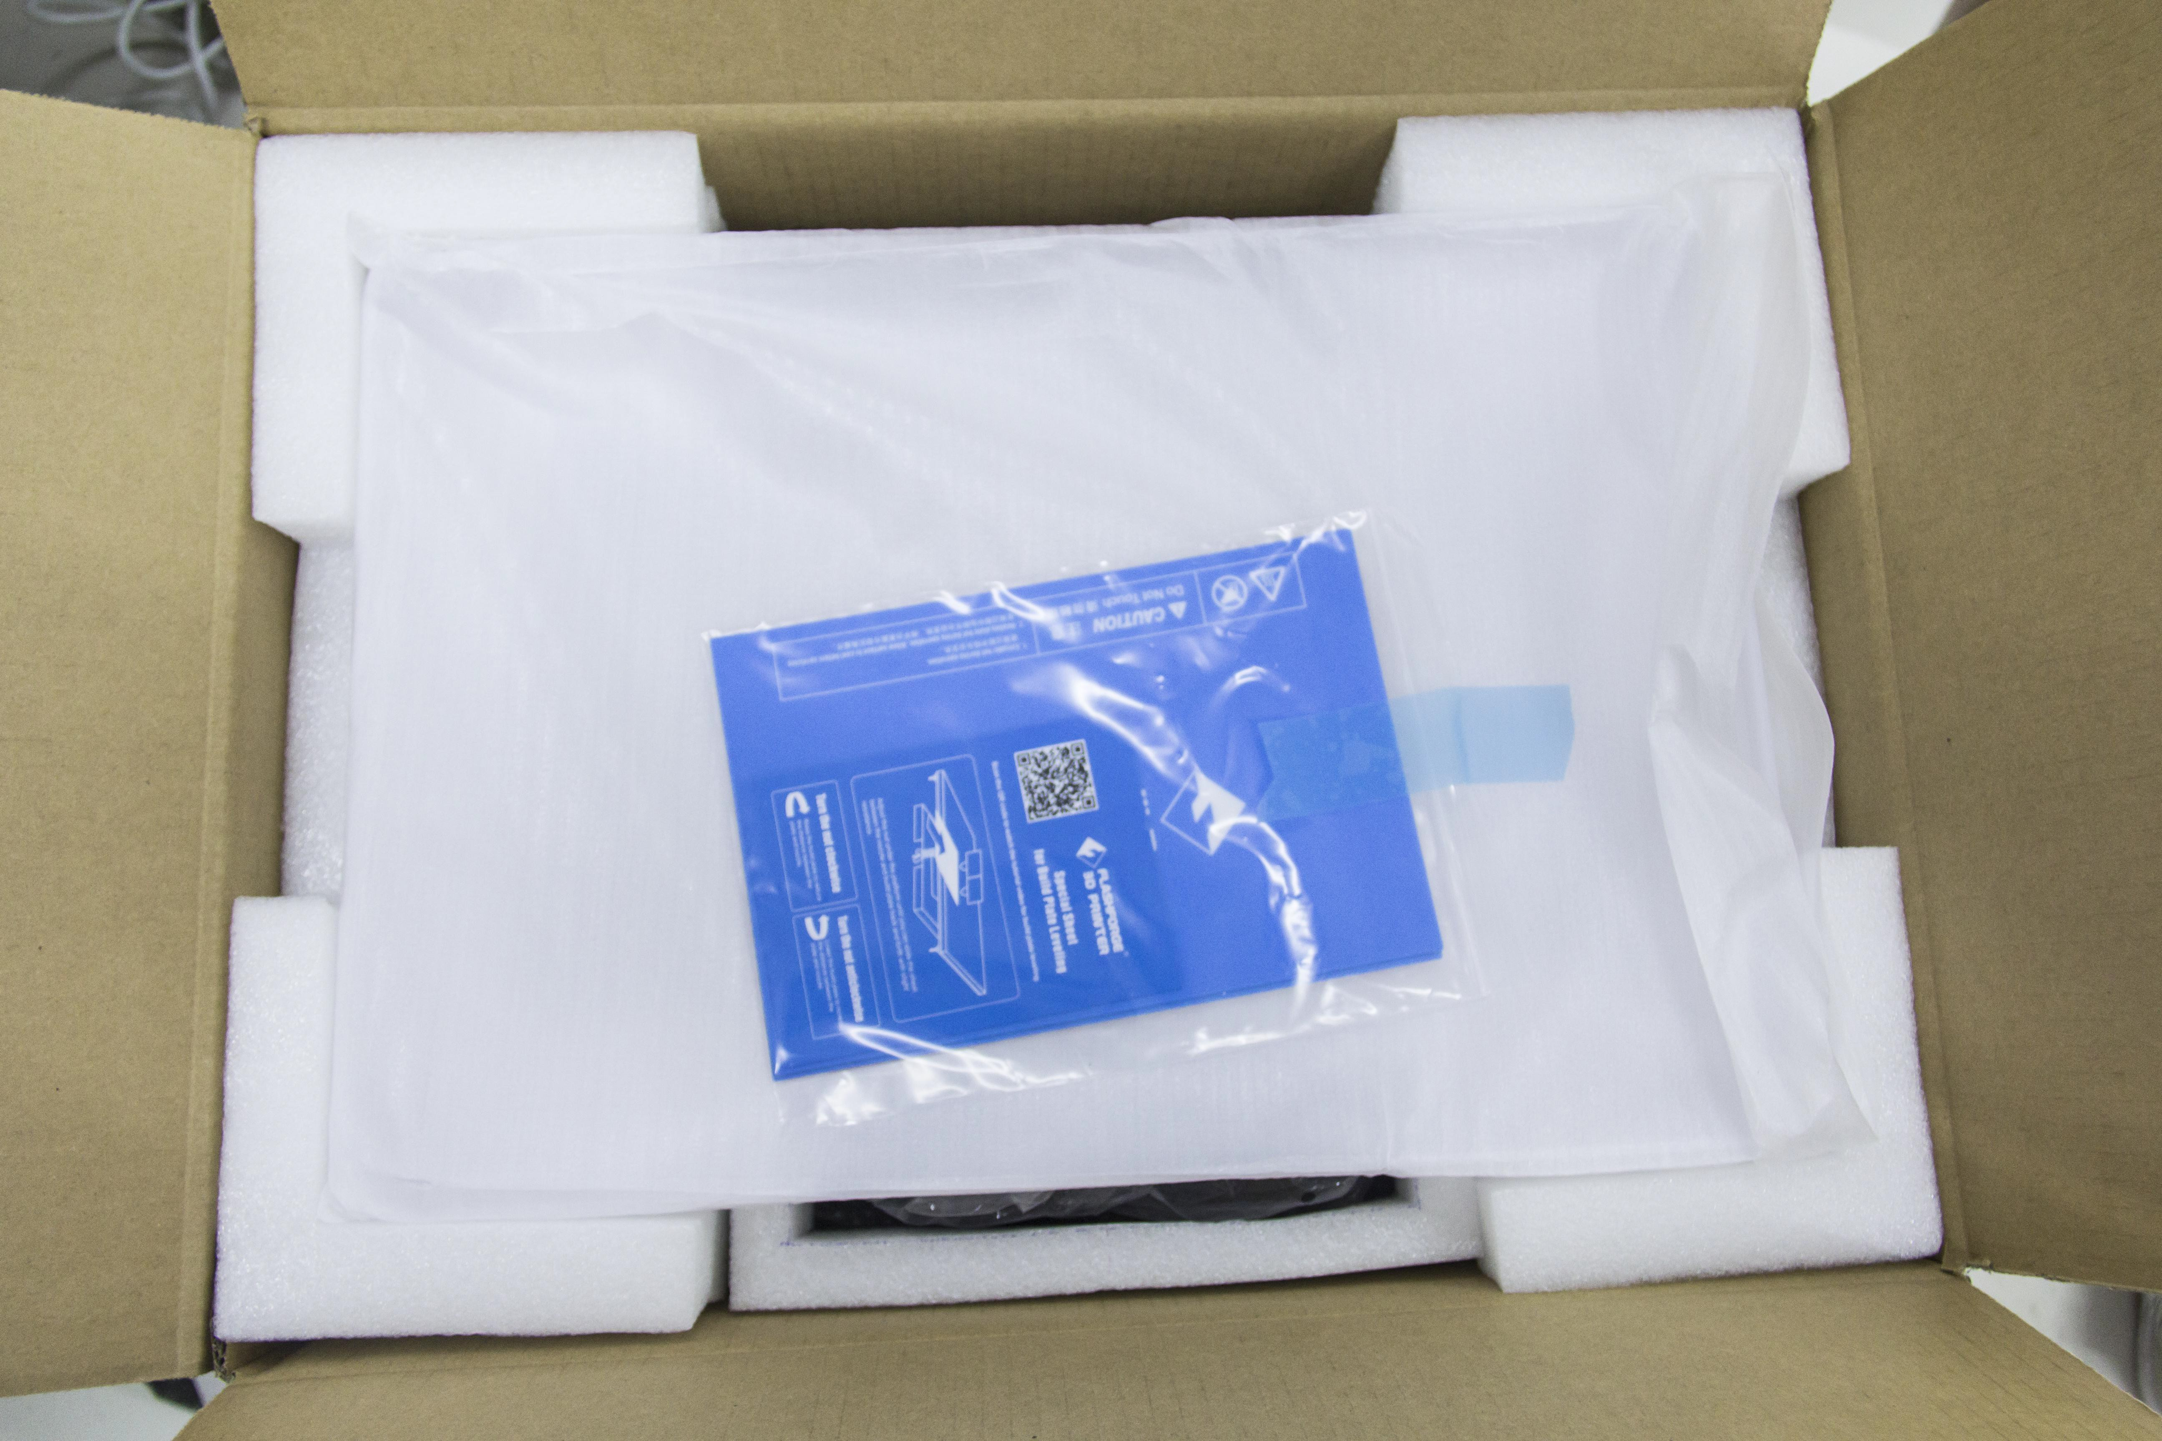
tape ,then you can see two pieces of Build Tape, a Leveling Card, a After-sales Service Card and a Quick Start Guide, which will guide you know our Inventor 3D Printer.

3-1
- （3-2）Remove the top protective foam pieces, which also houses the Inventor’s lid. Set this aside for now. The Inventor unit and a Power Cable will then be exposed.
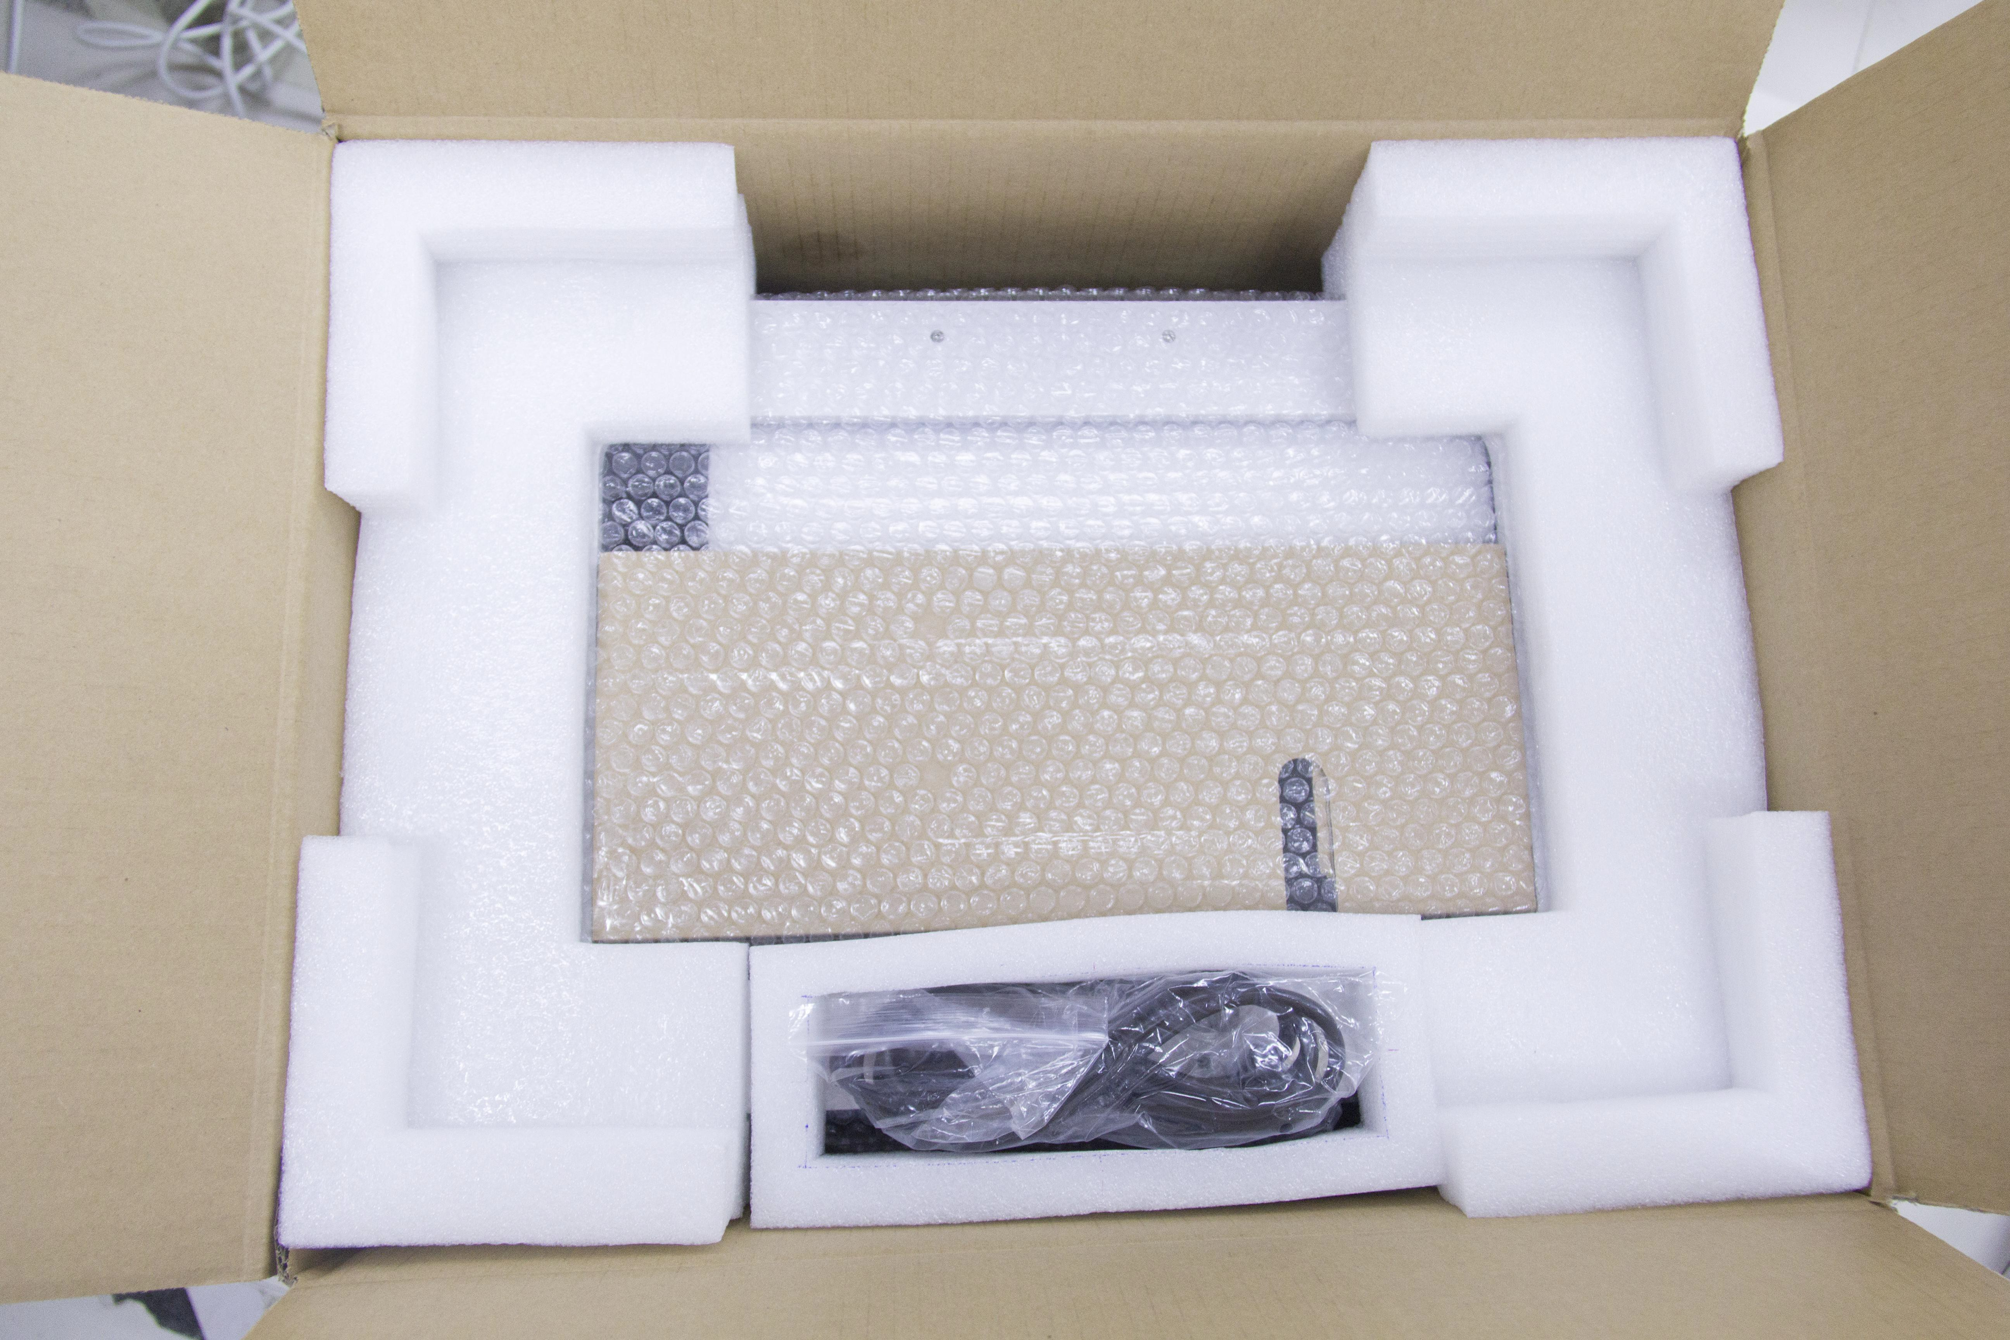
3-2

- （3-3）Lift the Inventor by its side openings and place it on a flat surface. Then you will see the Toolbox and USB cable in the shipping box. In the Toolbox, you can

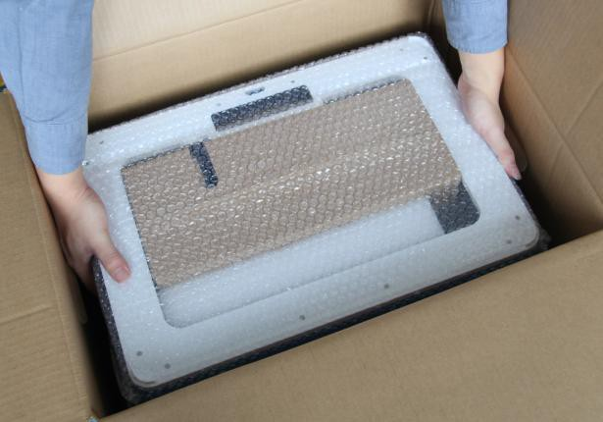
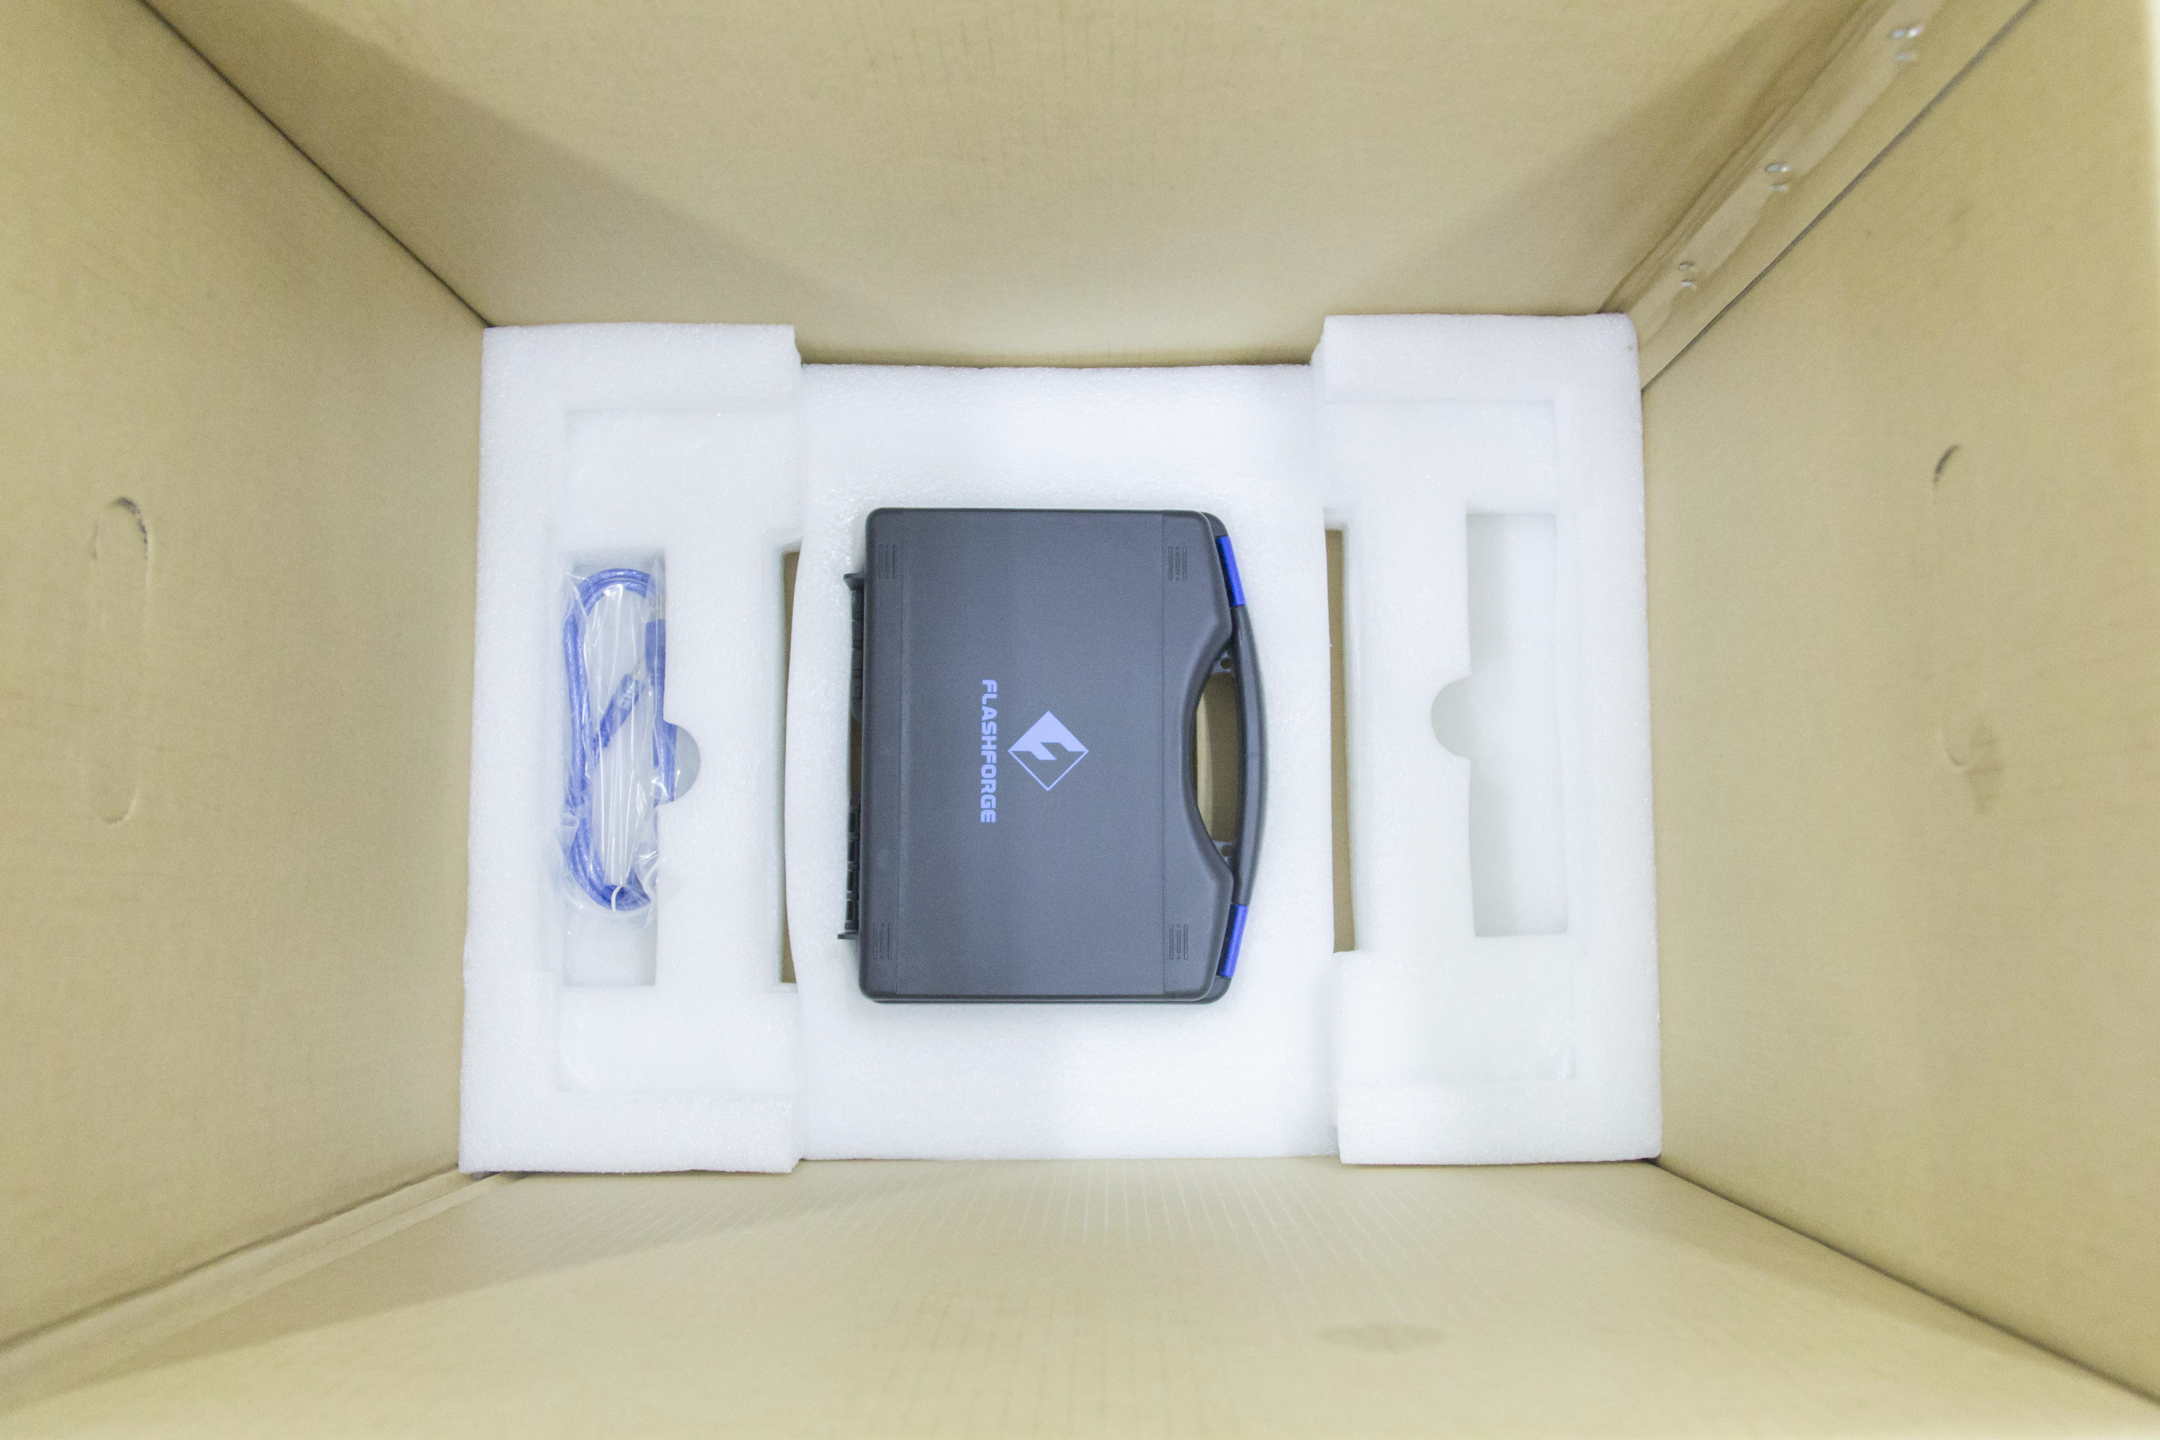
find a Carving Knife, a Scraper, a bag of Grease, Tweezers and a Screw Box. What's more, a SD card, some screws, Leveling Knob and two PTFE Tube in the box.

3-3
4.（3-4）The Inventor will have an accessory box on top of it, which will contain the
extruder set. Remove the box and the foam pad from the Inventor, and gently lay the extruder set on the Inventor build plate.
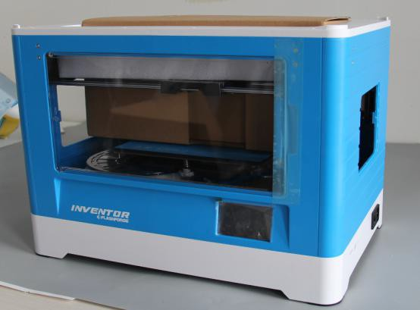
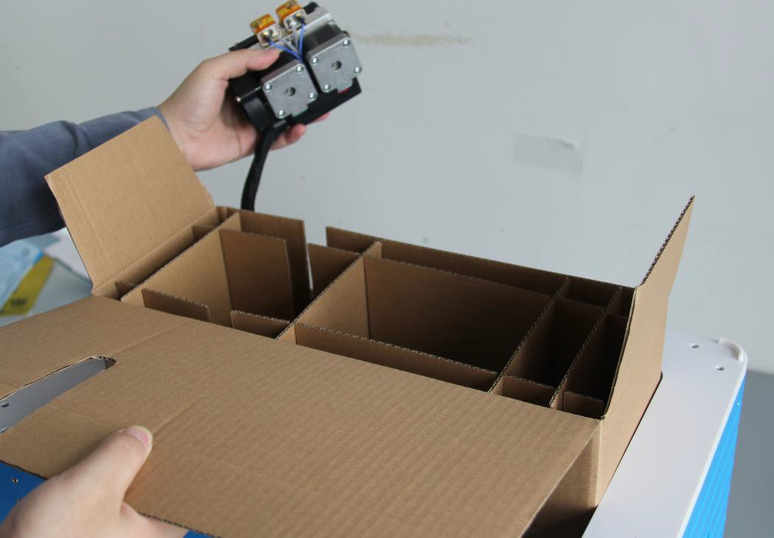
Inside the accessory box, you will find an Extruder Accessory Kit and two pieces of removable side panels.

3-4
Use scissors to cut ties
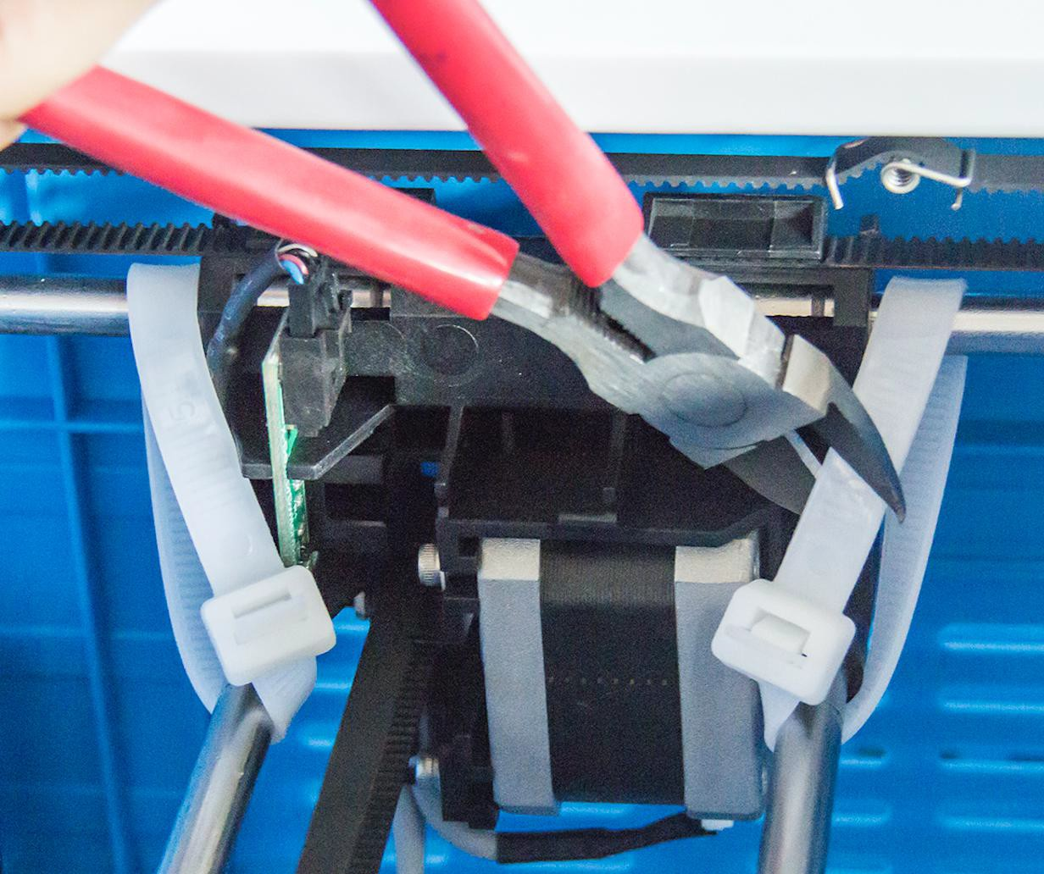
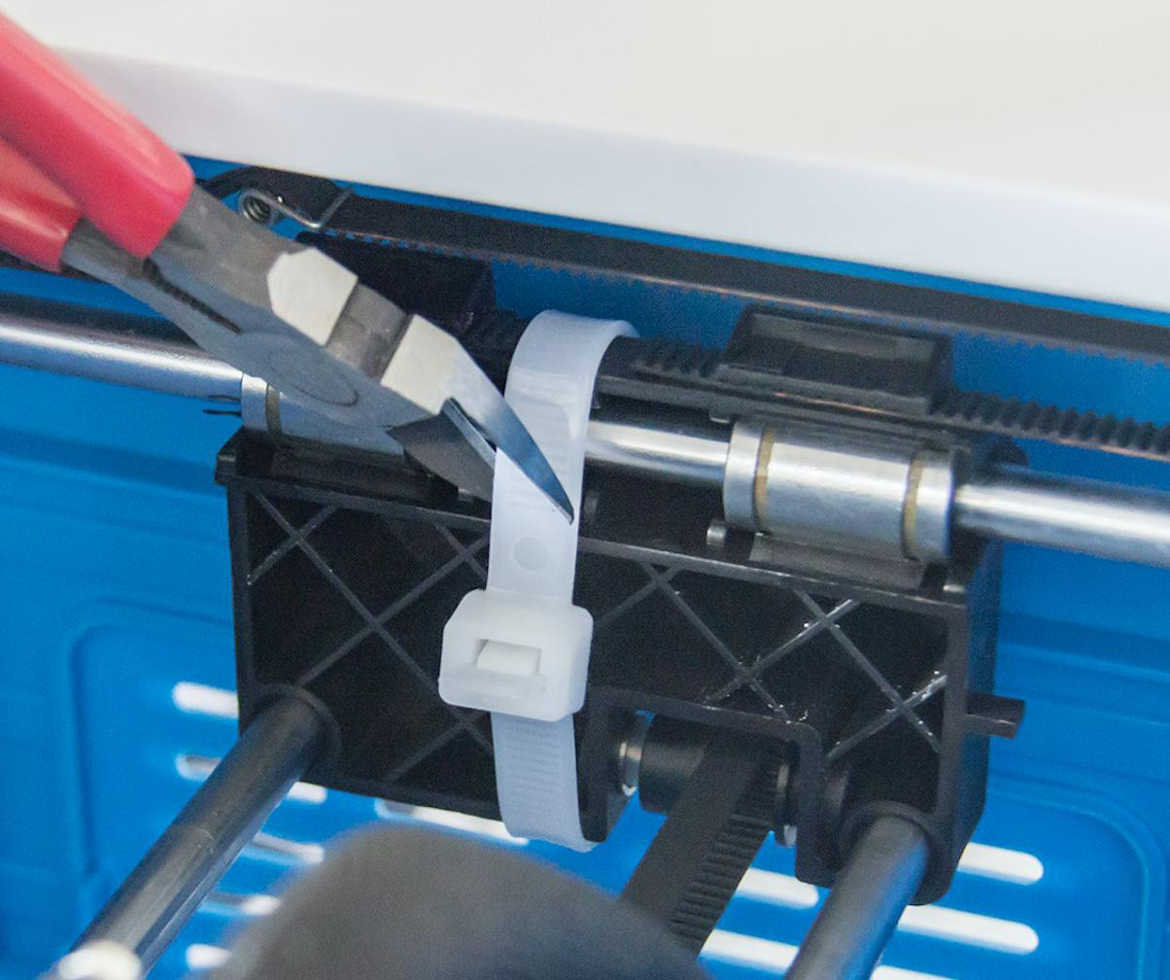

- (3-5) Move the build plate up carefully.
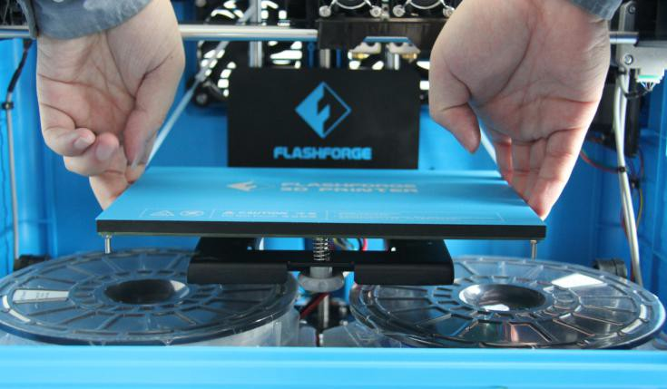
3-5

- (3-6)Take out the two PLA filament carefully which is under the build plate.
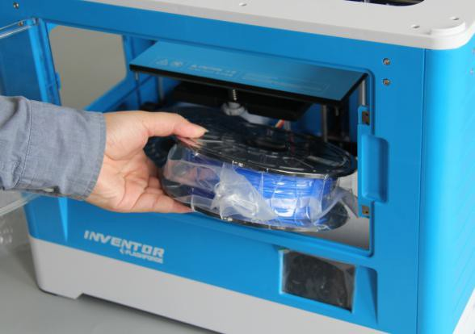
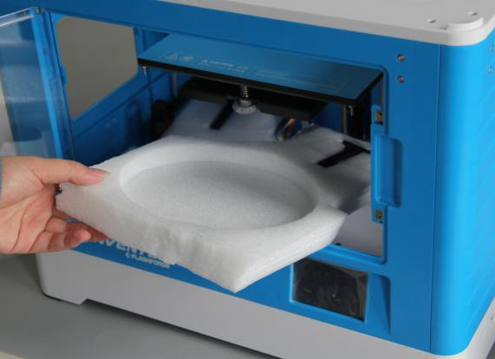
3-6

(3-7)You’ve finished unpacking your Inventor. Next we will move on to the hardware assembly.
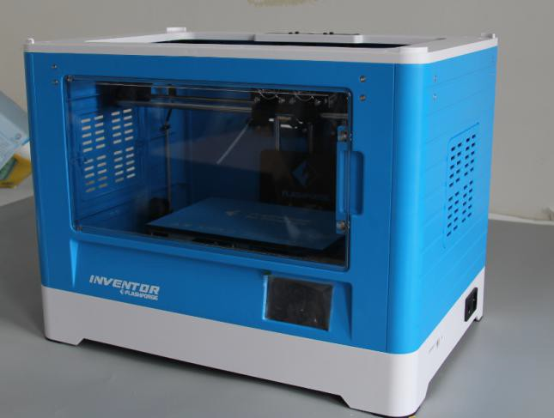

3-7

Chapter 4 . Hardware Assembly

The Inventor comes pre-assembled and is almost ready-to-print (ARP). All you need to do is to set the appropriate voltage, mount the extruder set, and install the filament. It will only take 5 to 10 minutes to set up the Inventor and prepare for your first 3D print!

Mounting the Extruder Set
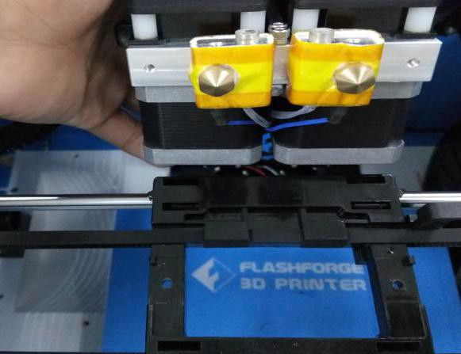


4-1
(4-1) Lay the extruder set on top of the extruder seat with the two extruder fans facing the front.
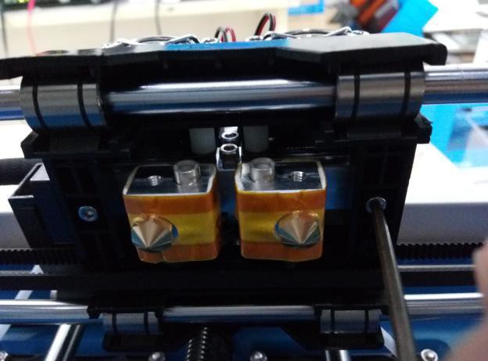

4-2
(4-2) Secure the extruder set onto the extruder seat with two M3x12 from the bottom up.

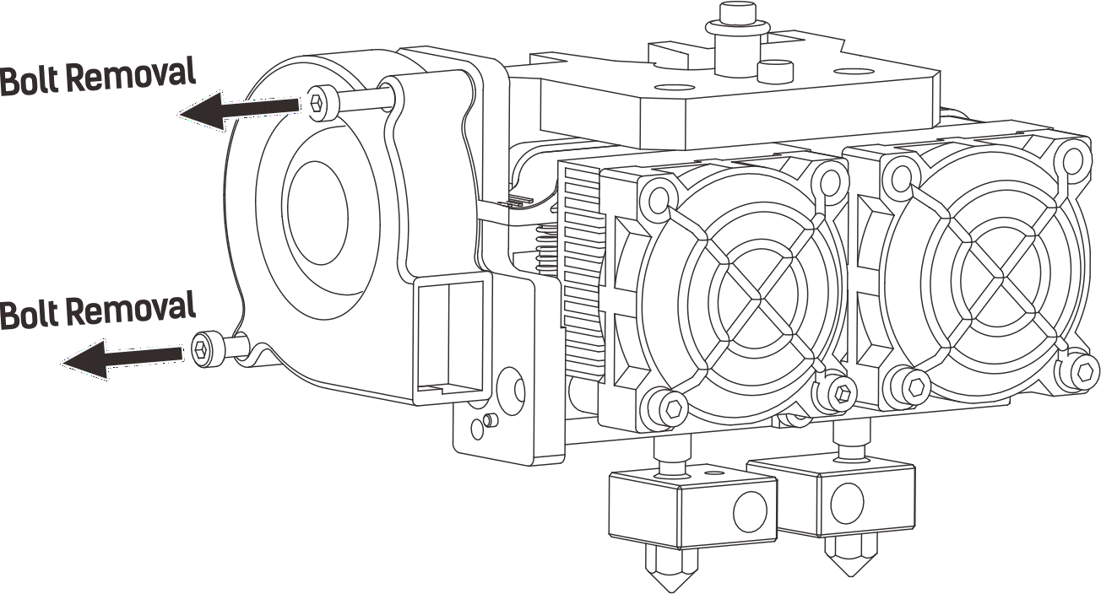
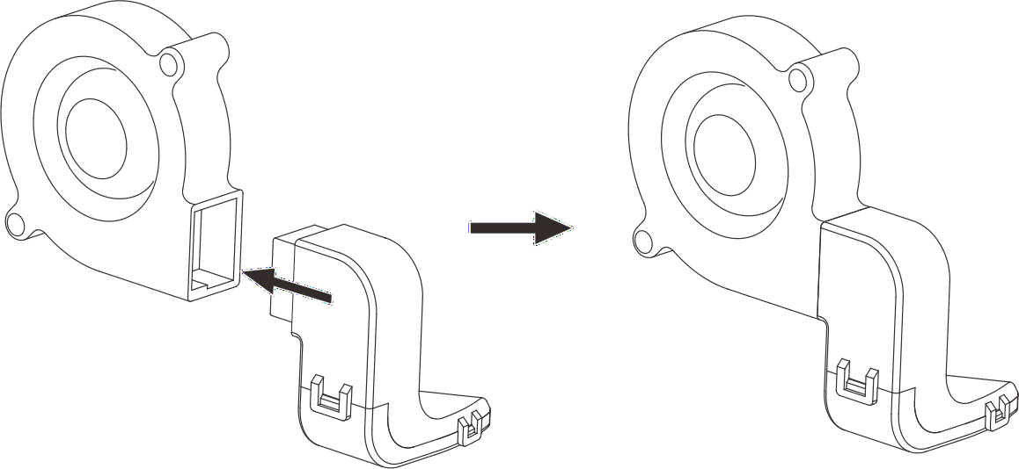
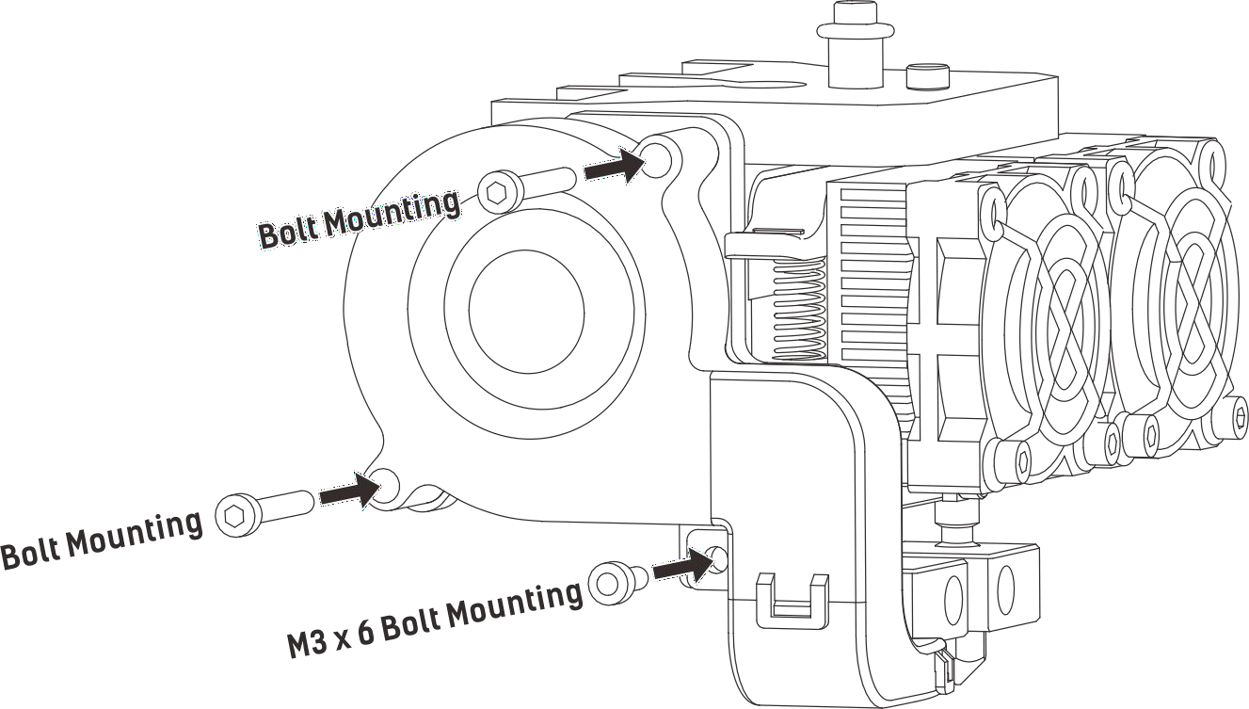

4-3
(4-3) Use the M2.5 Allen Wrench to unscrew two turbofan bolts. Take the turbofan baffle from the extruder’s accessory kit. Install the turbofan baffle to the turbofan. Align the bump on the turbofan seat to the hole in turbofan sub-assembly. Place the turbofan sub-assembly besides the turbofan seat. Insert the bump on the turbofan seat to the turbofan sub-assembly. Screw the two bolts in. Take a M3 x 6 bolt from the extruder’s accessory kit and complete installation.

  - Installing Filament
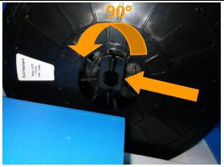
4-4

(4-4) Lock the filament in place by securing it with the filament spool holder and turning it counter-clockwise.
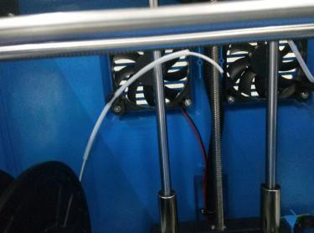
4-5

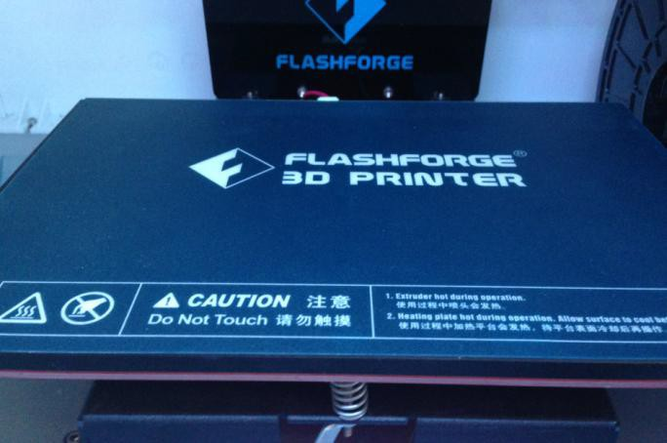
(4-5) Feed the filament through the filament guide tube. Attach the guide tube onto the two filament guide tube brackets.
4-6

(4-6) Stick the build sheet to the build plate after installing filament, as picture shows.

Plugging in Power Cable&USB Cable

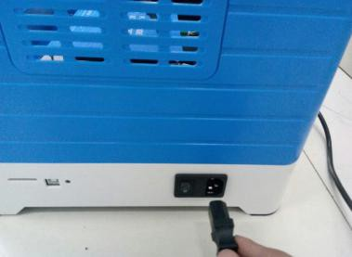
4-7
(4-7) Locate the power cable, and plug it into the Inventor.
Optional: Locate the USB cable and plug one end into the Inventor and the other into your computer. The Inventor supports USB connectivity.

Loading and Unloading Filament

Filament must pass through the extruder and into the heating block in order to be melted. In this user guide, we will demonstrate loading and unloading filament using the left side extruder.

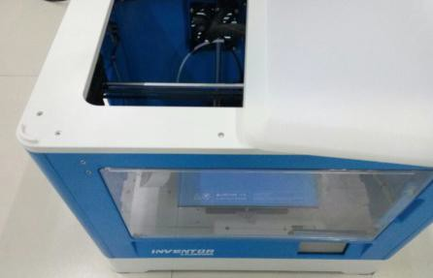
Loading filament:

4-8
(4-8) Remove the lid of the Inventor

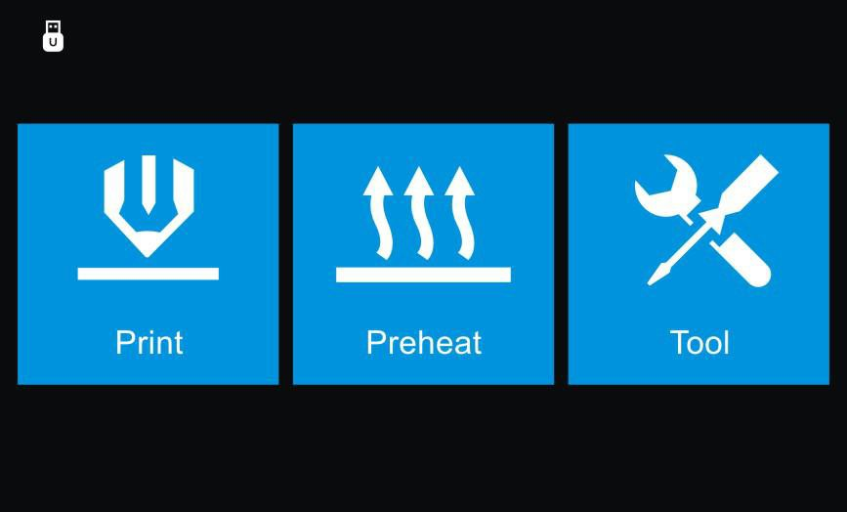
4-9
(4-9) From the main menu, tap the right icon labeled [Tool].


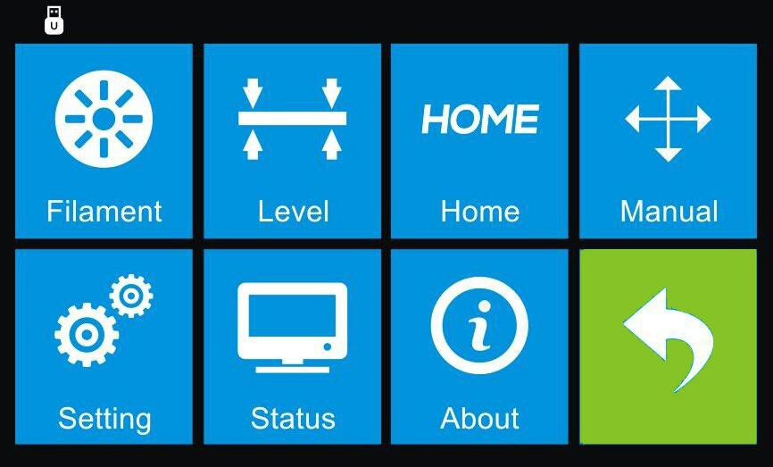
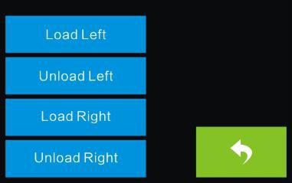
4-10
(4-10)Tap [Filament] and [Load Left].
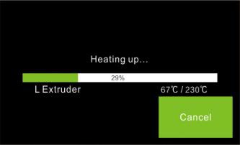
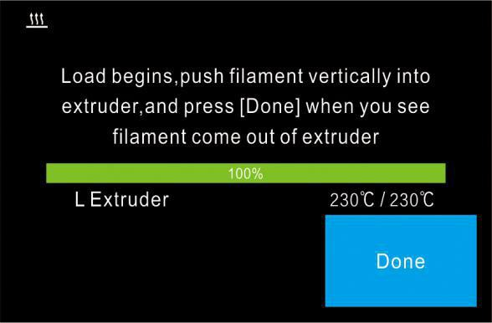
4-11
(4-11)Wait for the extruder to heat up to the operating temperature. The extruder will alert you once it is at the operating temperature. Load the filament by inserting it into the extruder at an upright angle.

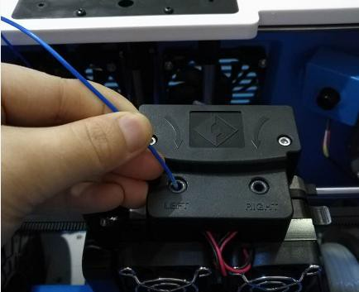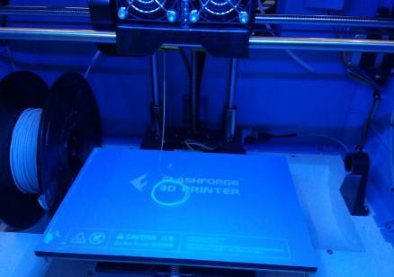
4-12

(4-12) Filament will start to extrude out of the nozzle. Continue loading to ensure that the filament is extruding in a straight line. Refer to the troubleshooting section if the filament is extruding abnormally. Then tap [Done] to finish loading.

Unloading filament:

(4-13) Remove the lid of the Inventor
4-13

4-14
(4-14) From the main menu, tap the right icon labeled [Tool].


4-15
(4-15) Tap [Filament]-[Unload Left].

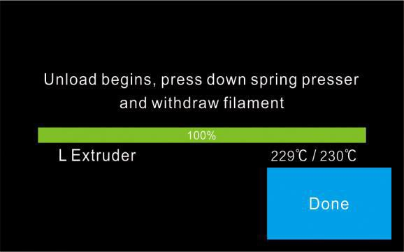
4-16
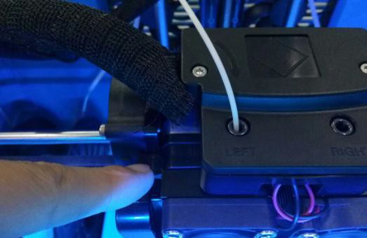
4-17

(4-16)Wait for the extruder to heat up to the operating temperature. The extruder will alert you once it is at the operating temperature.（4-17）Unload the filament by gently guiding it out of the extruder. Then tap [Done] to finish unloading.

Chapter 5: Build Plate Leveling
A correctly leveled build plate is almost a guarantee for a high-quality 3D object. When there is something wrong with the printed objects, you should check whether the build plate is leveled or not firstly. A general rule of thumb is to leave a gap that is the thickness of a piece of paper. However, for printing finer objects (150 micron and lower), please use a feeler gauge to level the build plate as it requires a lesser gap between the nozzle and the build plate.

The Inventor utilizes a three-point leveling system for its build plate. At the bottom of the build plate, there is one spring-loaded knob in the front and two in the back. Tightening the screw will create a bigger gap between the build plate and the nozzle while loosening it will create lesser gap.
5-1
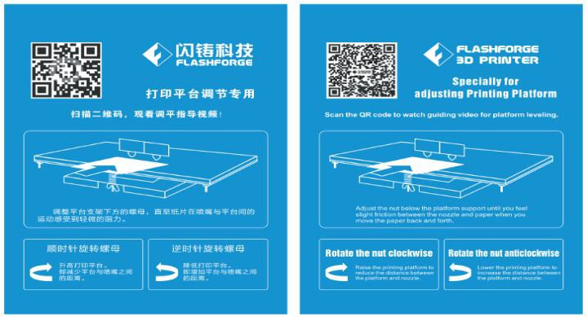
- （5-1）From the main menu, tap [Tool]-[Level]. The extruder and the build plate will begin to move to the starting position.

5-2

- （5-2）Take out the leveling card (Leveling video can be acquired by scanning the QR Code)
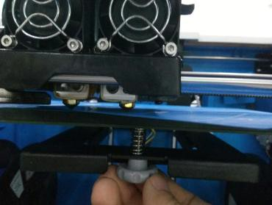

5-3
- （ 5-3）Once the extruder and build plate stops moving, slide the piece of paper continuously back and forth between the nozzle and the build plate. And simultaneously adjust the knob just enough so that the paper causes a slight friction.
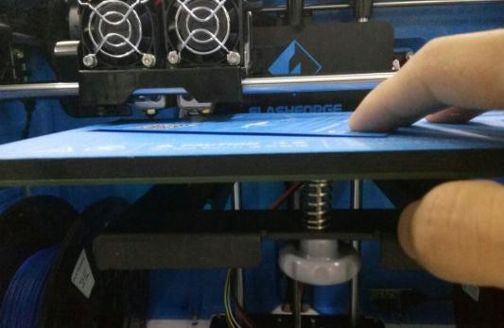
5-4
- （5-4）Tap [Next] and wait for the extruder to move to the second position. Slide the paper back and forth again, and adjust the screw to create the same amount of friction as the previous step.

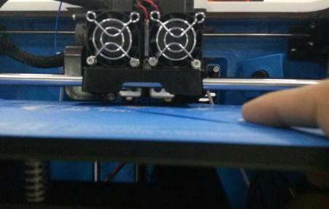
5-5

- （5-5）Tap [Next] again and repeat the same leveling steps.
5-6
- （5-6）Tap [Next]. The nozzle will move to the center of the build plate. Slide the paper through to make sure there is a slight friction. Slowly adjust all the screws by the same amount if there is no friction or too much friction.
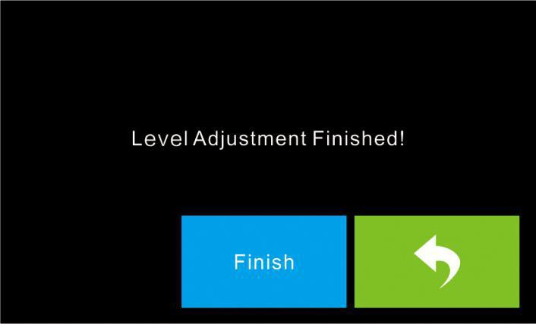
5-7
- （5-7）Tap [Finish] once you have finished this.

Chapter 6: About Software
This chapter talks about the basic function of FlashPrint. For more information about advanced function, you can browse our website www.FlashForge.com.

Software Installation

    - Software Acquisition

Method 1: To get the installation package from the SD Card in the toolkit.
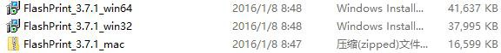

Method 2: Open the link below to download the installation package: http://www.FlashForge.com

Support---Downloads---FlashPrint---Choose the Software Version---Download

    - Software Installation and Start-up

- Decompress the zipped file or start the installation program, and then install the software according to the direction.
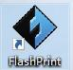
- Click the software icon to start the software with the start menu shortcut.(See 6-1)
6-1

Exploring FlashPrint

6. 2.1 Machine Type Selection

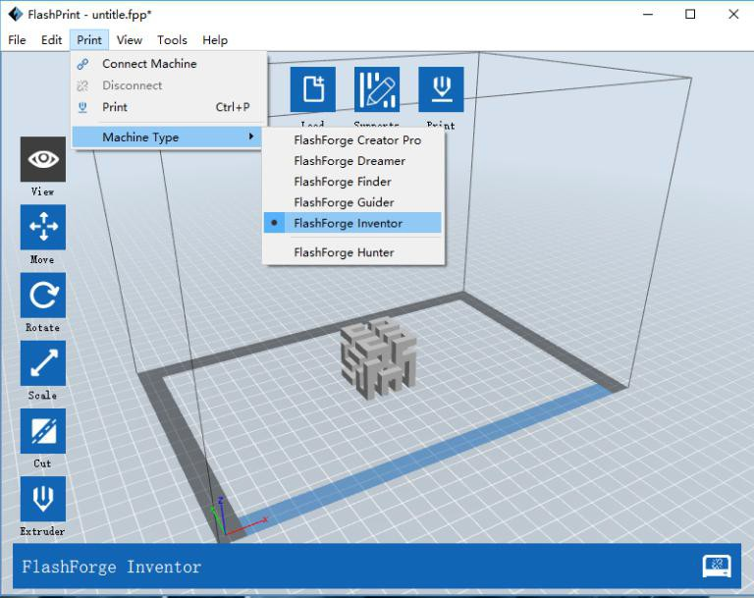
Notice! After starting FlashPrint, you need to select the target machine type first. When you start FlashPrint, a dialog box will pop up. Just need to select FlashForge Inventor in the machine type list and click [OK]. You can also change the machine type via clicking [Print]--[Machine type]. Please see graphic 6-2:

    - FlashPrint Menus
6-2

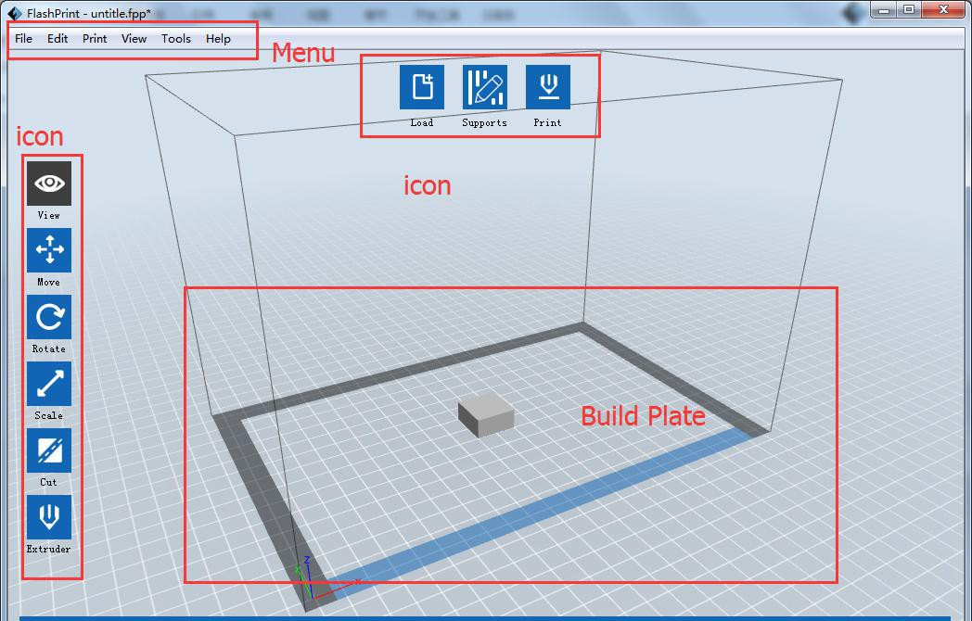
6-3

 | Load files.
 | Enter the support edit mode
 | View FlashPrint home screen from one of six viewing angles.
 | Move model around on XY-plane; shift+click to move along Z axis
 | Turn and rotate your model
 | Scale the size of your object
 | Cut the model into several parts
 | Print it directly with your Inventor or export to your SD card.
 | Select right or left extruder you want to print with.
    - Loading
You can load a model file or Gcode file into your FlashPrint by the following six methods:
Method 1: Click the Load icon on the main interface. Then select the object file.
Method 2: Select the file for loading and drag the file to the main interface of the software.
Method 3: Click [File]--[Load File]. Then select the object file for loading. Method 4: Click [File]--[Examples] to load the example files

Method 5: Click [File]--[Recent Files] to load the files opened recently. Method 6: Select and drag the target file to the icon of FlashPrint.
Note: 3D models can be stored by .STL, .OBJ, .3MF or .FPP flies and supported by
FlashPrint for editing. Generating Rilievo
Load a png, jpg, jpeg, bmp picture file into the FlashPrint. And the following dialogue box (6-4) will pop up. The setting box includes settings for shape, mode, maximum thickness, base thickness, bottom thickness, width, height, top diameter and bottom diameter.
Shape: including plane, tube, canister and lamp.
Mode: including “darker is higher” and “lighter is higher”. Maximum thickness: Z value of the model
Base thickness: The minimum raft thickness and the default value is 0.5mm Width: X value of the model
Depth: Y value of the model
Bottom thickness: To set up bottom thickness for tube, canister, lamp and seal. Top diameter: To set up the top diameter for tube, canister, lamp and seal.
Bottom diameter: To set up the bottom diameter for tube, canister, lamp and seal.
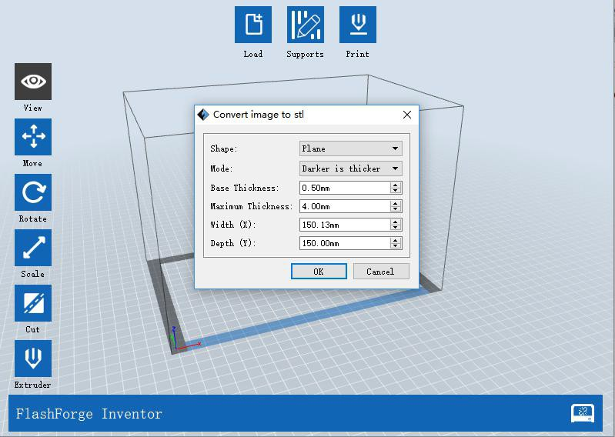
6-4

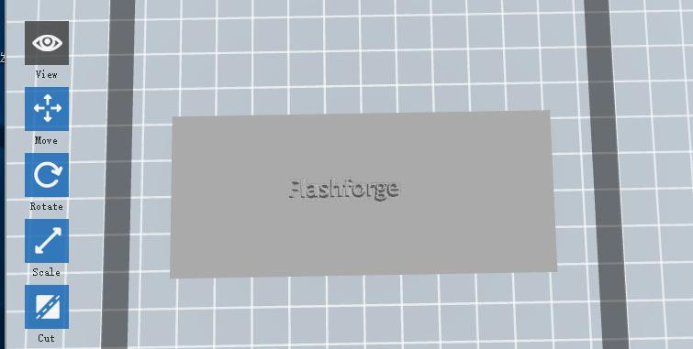
Plane 6-5
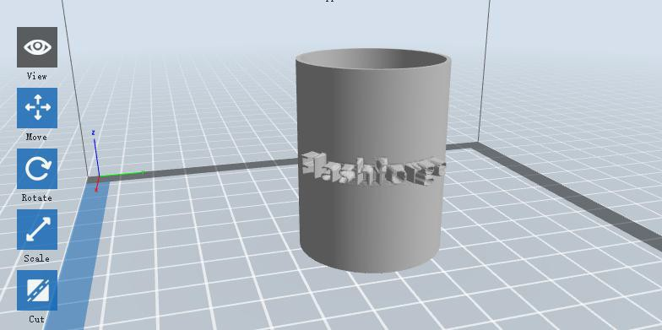
Tube 6-6
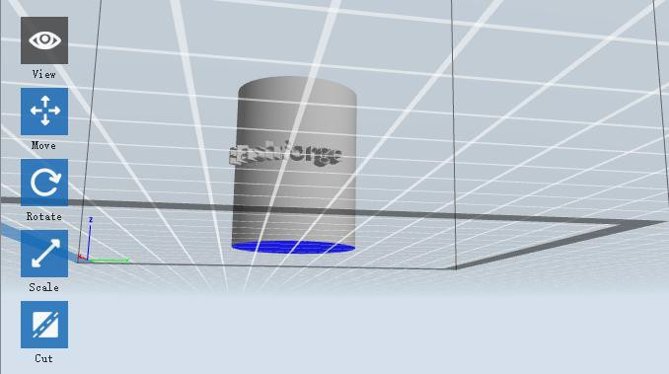
Canister 6-7

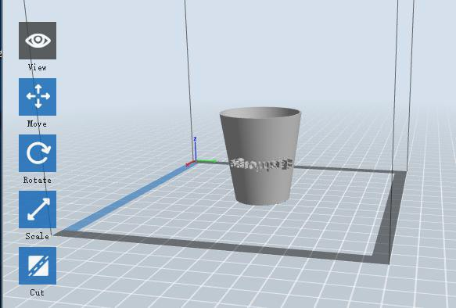
Lamp 6-8
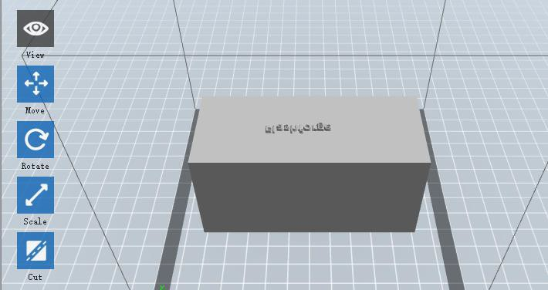
Seal 6-9

    - Views

① Changing views
Change model views by moving, rotating, scaling.

Drag
Click the [View] icon and then you can move the object by the following three methods:
Method 1: Hold down the left mouse button and drag.

Method 2: Hold down the mouse wheel and scroll up and down.
Method 3: Hold down the Shift key, hold down the right mouse button and drag.

Rotate
Click the [View] icon and then you can rotate the object by the following two methods:
Method 1. Hold down the right mouse button and drag.
Method 2. Hold down the Shift key, hold down the left mouse button and drag.

Scale
Rotate the mouse wheel to enlarge or shrink the build plate.

② Set View
Allow users to view the object on the build plate. Six views are under the view menu, that is, bottom view, top view, front view, back view, left view and right view.

Method 1: Click the the [View] button, there are six views in the drop- down list Method 2: Click the the [Look] icon on the left, click it again and a submenu will appear with six views for selecting.

③ Reset View
Allow users to reset views by the following two methods:
Method 1: Click the [View] menu and select [Home View]
Method 2: Click the [View] button on the left, click it again and you will see the viewing options, you can click [Reset].

④ Show Model Outline
Click [View]--[Show Model Outline], it will highlight the yellow border of the object

⑤ Show Steep Overhang

Click [View]--[Show Steep Overhang]. When the intersection angle between the model surface and horizontal line is within the overhang threshold value, the surface has steep overhang and it becomes red in the software. Overhang threshold value could be set as needed. The default value is 45 degree.

Move
Select the object and move the object by the following two methods:
Method 1: Click the [Move] icon  on the left, hold down the left mouse
button and drag to adjust the location of the model in XY direction. Hold down the Shift key, hold down the left mouse button and drag to adjust the location of the model in Z direction. The distance and the direction of the movement shall be displayed.
Method 2: Click the [Move] button on the left and then enter the distance value. Click [Reset] to reset distance values.
Note: Users shall click [Center] and [On Platform] after the location adjustment to ensure the model(s) be within the build area and on the build platform. If a specified position is needed, only click [On Platform].

Rotate
Select the target object and rotate the object by the following two methods:
Method 1: Click the [Rotate] icon on the left and three mutually
perpendicular rings appear around the object Click one ring and rotate on the present axis, you will see the rotation angle and direction in the center of circle. In this way, you could make the model rotate on X/Y/Z axis.

Method 2: Click the [Rotate] icon on the left, and then enter into rotating angel values in X/Y/Z axes positioning. Click [Reset] to reset rotating angel values.

Scale
Select the target object and scale the object by the following two methods:
Method 1: Click the [Scale] icon on the left, hold down the left mouse button and scale the model. The corresponding values will display near the object..
Method 2: Click the [Scale] icon  on the left and then enter into scale values in X/Y/Z axes positioning. Click the [Maximum] button to get largest size possible for building. Click [Reset] to reset the size of model.
Note: If the [Uniform Scaling] radio button is clicked, it will scale the model in equal proportion when changing value in any positioning of the model. Otherwise it will only change the value of the corresponding positioning.

Cut
Left-click on the model to select it and double-click on the [Cut] icon to set the cut plane. The direction and position are available for setting.

①Draw with Mouse
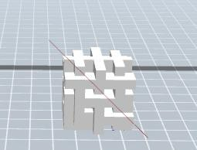
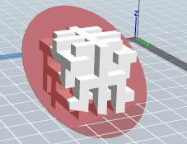

②X Plane
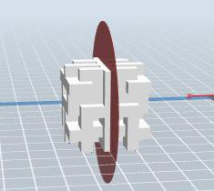
③Y Plane
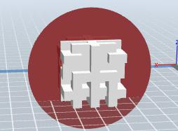
④Z Plane
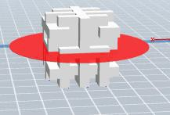

    - Extruder

(6-10) Choose L/R extruder to print, pitch on the model, click on  two times, now you can set extruder .

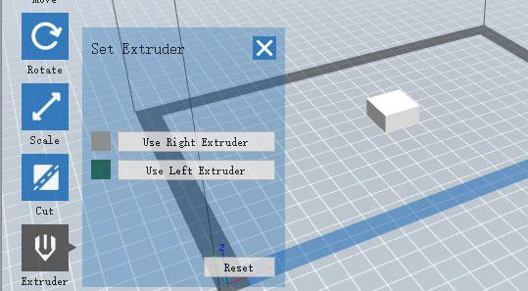
6-10

    - Supports
After loading the model, click [Edit]--[Supports] or click the Supports icon  directly, then you will enter the support edit mode (6-11). Click [Back] to exit when you finish editing.
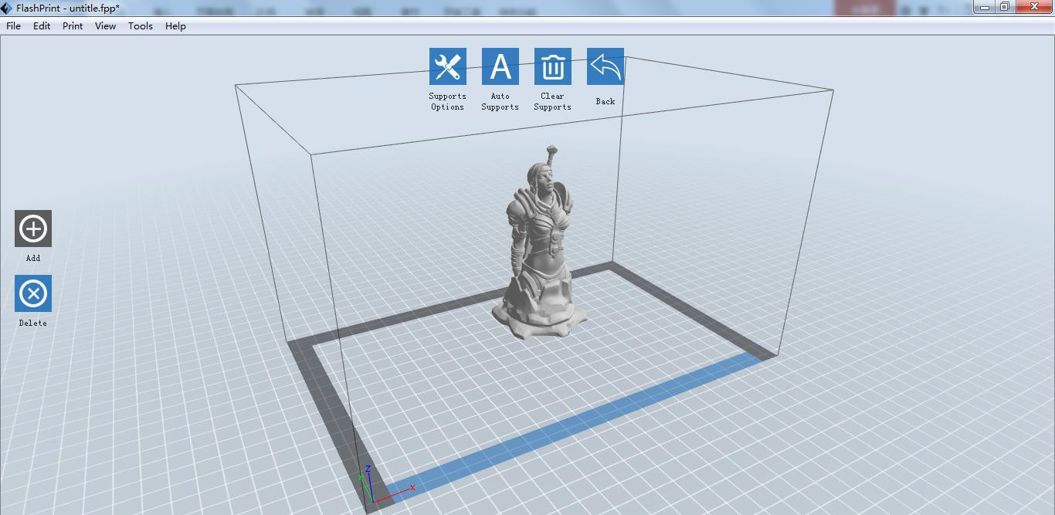

①Support Options
6-11

Click the Support Options, an option box will appear, supports options include “treelike” and “linear”, when choose “treelike”, click [OK], then the support generated will be treelike structure; when choose “linear”, click [OK], then the support generated will be linear structure; if the model already had support, when you

choose one of the supports options, software will judge whether existing supports need to be deleted or not depend on the type of existing support, and will pop up the corresponding prompt to let you make the choice.
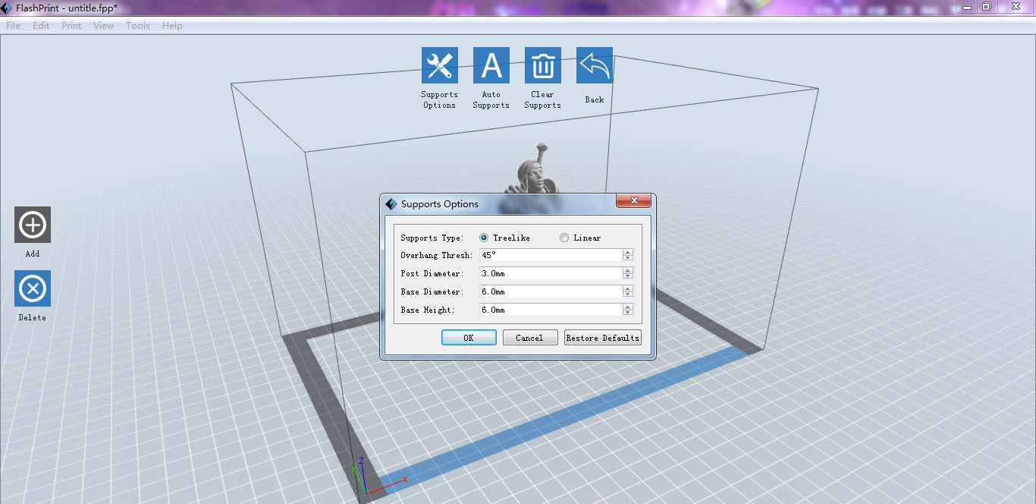

6-12

② Auto Supports
Click the [Auto Supports] button, the software will judge the position where supports are needed and generate corresponding treelike or linear supports. If the model already had support, the existing supports will be deleted and new supports will be generated.

③ Add Supports
Supports will be added once clicking the [Add] button. Move the cursor to the position where needs supports, left-click to choose the starting point of supports, hold down the left mouse button and drag the mouse the supports preview will show up(if support surface doesn’t need support or the support column angle is too large, will highlight the support review ).Loosen the left mouse button, if support column doesn’t meet with model, then support will be generated on origin and terminal point(the highlighted preview support won’t generate support structure )

④ Clear Supports
Click [Clear Supports], all supports will be deleted. The operation can be repealed via clicking [Undo] or pressing the shortcut key Ctrl+Z.

⑤ Delete Supports
Supports will be deleted once clicking the [Delete] button. Move the cursor to the supports needed deleting, current supports and its child node support will be highlighted, click the left mouse button to delete these highlighted support.

    - Print
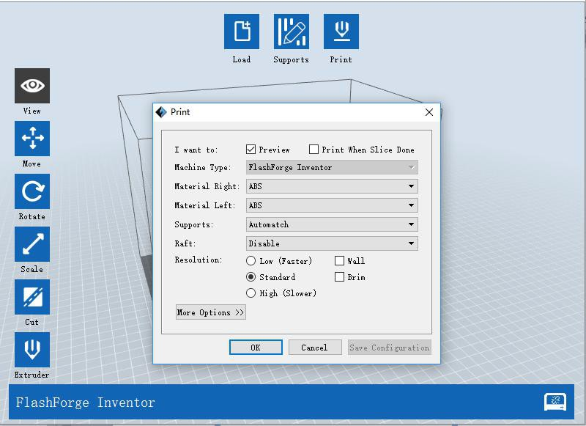
6-13

① Preview: Choose to enter preview interface or not
② Print when slice done: Print or not when slice done

③ Material Right/Left: Choose according to the type of model

④ Supports: When print with model contains part hanging in the air or top-heavy, support is necessary. Click [Supports] to create support part for the printing.
⑤ Raft: This function will help the model to stick well on the platform.

⑥ Wall: During dual color printing, this function will help to clear the leaking filament of another extruder.
⑦ Brim: Expand the outline of model’s bottom layers to a Brim which helps anchor the edges of the model to the plate to avoid warping.
⑧ Resolution ： You have three resolution solution (with default setting)to choose from, high resolution is corresponding with slow printing speed, opposite for the low
resolution. For PLA printing, an extra solution “Hyper” is available.

⑨ More options: Click [More options] to set for layer, shell, infill, speed and temperature. Different resolution solution is corresponding to different defaults, click [Restore Defaults] to back to default setting.

Layer
- Layer: Layer thickness of the printing model. With a small number, the surface of the model will be smoother.
- First Layer Height: This is the first layer of the model, which will affect the sticking performance between the model and platform. Maximum is 0.4mm, usually the default is ok.
- Shell: Contains of the outside shell number, capping layer number (under vase pattern, top solid layer setting is invalid.)
- Perimeter Shells: Maximum is 10
- Top Solid Layer: Maximum is 30, minimum is 1.
- Bottom Solid Layer: Maximum is 30, minimum is 1.

Infill
- Fill Density means fill rate.

- Fill Pattern is the pattern of filling shape which effects printing duration.
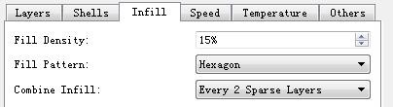
- Combine Infill: You can select the layers for combining according to the layer thickness. The combined thickness should not exceed 0.4mm. “Every N layers” is for all the infills while “Every N inner layers” is only for inner infills, which generally can save print time.

6-14

Speed

        - Print Speed is the moving speed of the extruder. Generally, the lower the speed is, the better print you will get. For PLA printing, 80 mm/s is recommended.
        - Travel Speed is to control the moving speed of the extruder under
non-printing Status during work. for PLA printing, 100 mm/s is recommended. Note: Modify parameters settings to get better prints as different models need different parameters.

Temperature
Right Extruder Temperature: Recommended extruder temperature is 230℃.
Note: Different temperatures have subtle influences in prints. Please adjust the temperature according to the condition in order to get a good print.
Platform Temperature: To set the temperature of Platform.

Others
Cooling Fan Control: Set up the time to turn on the cooling fan. You can pre-set the height and make the cooling fan begin to work at the point.
Pause At Heights: Allows users to preset a height in which the print will suspend automatically. The function usually applied when you want to change the

filament at a certain point.
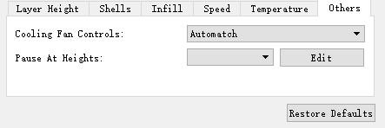
6-15
(6-15) Click[Edit], then you can add or remove a height.

    - File Menus

① New Project
Click [File]--[New Project] can build a blank project. If there is an unsaved modification on previous project, then will inform you whether the modification needs to be saved or not. Click [Yes] will save the modification, click [No] will abandon it. If click [Cancel] or close tool tip, then will cancel the new project.
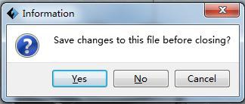

② Saving
6-16

After finishing the model edit and adjustment, there are two ways below to save all models in the scene.

Method 1:
Click [File]--[Save Project] in the menu bar, can save the file as a project file which suffix is ”.fpp” in this type of file,all models in the scene (include support) are independent .after reloading the files, extruder configuration information and model position will be same as the configuration during saving.

Method 2:
Click on [File]--[Save as...] to save the model as project file .fpp or .stl and .obj. For .stl and .boj, models are integrated as one(include support part). If load it again, only the position of the model is saved, not include the printing parameters.

③ Preferences
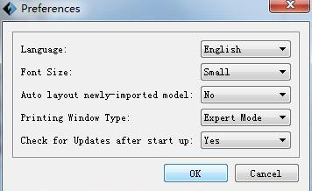
Click [File]--[Preferences], you can choose language and if when detecting update while start

6-17
- Language: The software supports six languages, that is Chinese (simplified Chinese and traditional Chinese), English, French, Korean, Japanese and Russian.
- Font Size: Set the font size.
- Auto layout newly-imported model: Set Yes or No.
- Printing Window Type: Including Basic Mode and Expert Mode
- Check for Update after start up: It is used to set if needs to activate the online automatic update function, if choose yes, every time when you open software, it can online detect if there is new version software, once new version found, it will reminds users to download and install new version firmware.

    - Edit Menus

① Undo
Allows users to undo the recent edits by the following two methods: Method 1: Click [Edit]--[Undo].

Method 2: Press the shortcut Ctrl+Z.
② Redo
Allows users to redo the most recent edit you have undone to your model file by the following two methods
Method 1: Click [Edit]--[Redo] Method 2: Press the shortcut Ctrl+Y.
③Empty Undo-stack
To clean up the recorded operating steps so as to release the memory.

④ Select All
By the following two methods, you could select all models in the scene. (When models are too small to be seen or out of viewing scope, please click [Center] and [Scale] buttons to adjust the model.)
Method 1: Click [Edit]--[Select All].
Method 2: Press the shortcut Ctrl+A.

⑤ Duplicate
Select the object and duplicate the object through the following two methods: Method 1: Click [Edit]--[Duplicate]
Method 2: Press the shortcut Ctrl+D

⑥ Delete

Select the object and delete the object through the following two methods: Method 1: Click [Edit]--[Delete]
Method 2: Press the shortcut Delete

⑦ Auto Layout All
Click [Edit]--[Auto Layout All] after loading one or more than one models, all models will be placed automatically as automatic placement rule.

⑧ Repair Models
Click [Edit]--[Repair Models] to repair models.

⑨ Supports

Click [Edit]--[Supports] to enter supports setting interface.

    - Print Menus

① Connect Machine
You can connect the Inventor with your PC via a USB cable or WiFi. Note: The machine icon on the bottom right displays the connection status: Connected

Disconnected

Method 1：Connect Via USB Cable
- Connect your Inventor with your PC via a USB cable.
- Turn on your Inventor and start FlashPrint.
- Click [Print]--[Connect Machine], then select USB in the [Connection Mode] option and select machine you want to connect in [Select Machine] option. If you can not find your machine, click the [Rescan] button to scan your machine and select it. Finally click [Connect] button to connect to the printer. If you still can not find your machine after rescan, which means you haven’t installed the driver in the software.
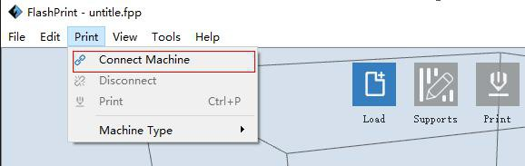
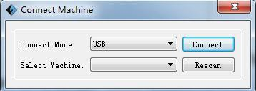

6-19

Method 2： Connect Via WiFi
- Turn on Inventor.
- Turn on Wi-Fi on the Inventor. Tap [Tool]-[Setting]-[WiFi]-[ WiFi ON].
- A connection called“Inventor 1” can be found on the your computer available networks list. Connect your computer to this network.
- Open your Internet browser in your computer. Type in “10.10.100.254” and hit [Enter] on your keyboard. Enter the username and password to login. The default username and password are both “admin.” The control panel will appear after a successful login.
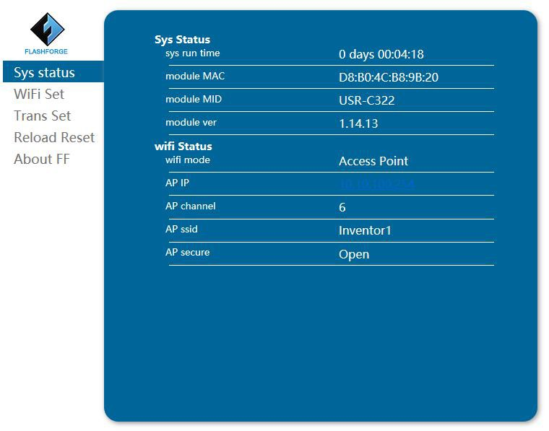

6-20

- Click on [WiFi Set] and choose“AP mode” or “STA mode”in WiFi Model Select and save it. Click [Restart] to take effect.

- AP Mode：You can set the network name(Inventor1) and password of the hotspot in AP mode. If you don’t want to set the password, select “None”. Then save and
restart it. Connect your PC to the network named “Inventor 1”. Open FlashPrint, click[Print]--[Connect Machine]. Under “Connection Mode”, select Wi-Fi, and enter the “IP Address” as shown on Inventor touch screen. Then, click [Connect].

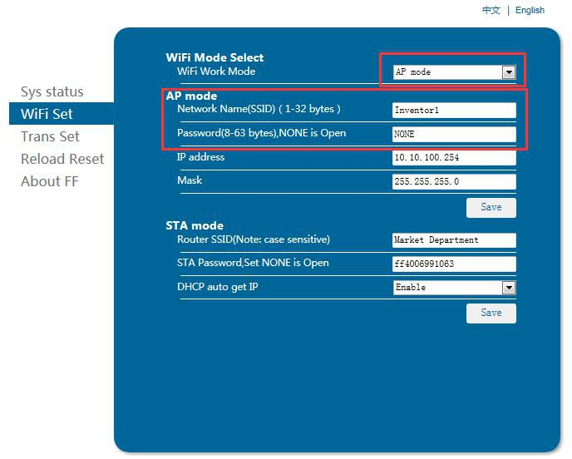

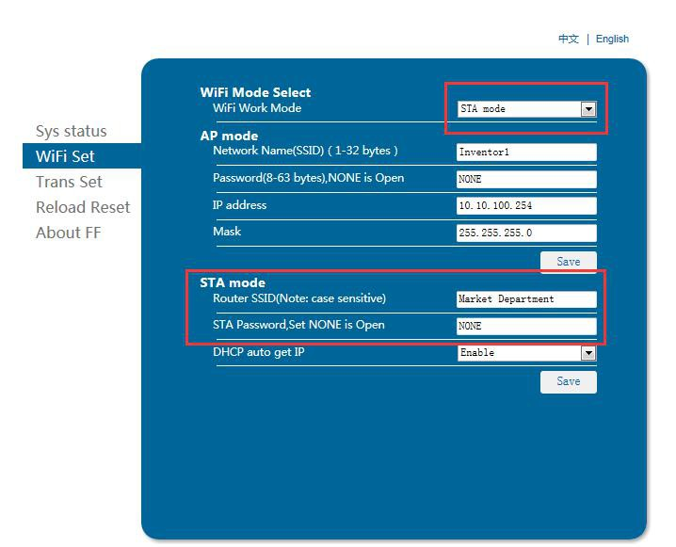
ST word
A Mode: Select a working network, enter the corresponding name and pass
d save in STA mode. Then save and restart it. Restart your Inventor and open wi
an fi.

6-22

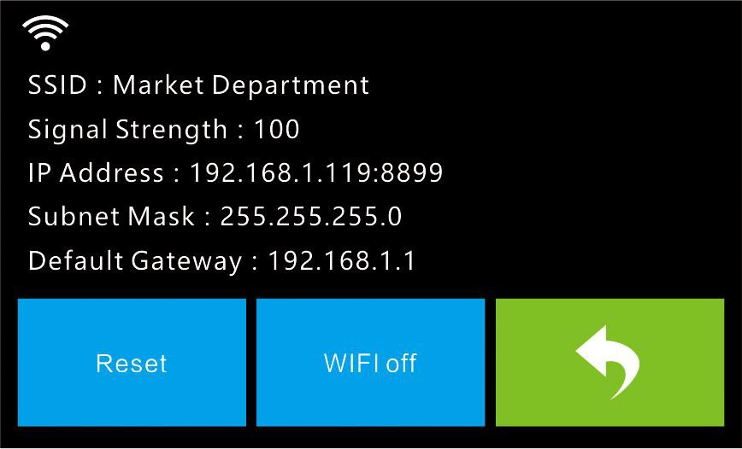

Turn on the Inventor again and connect your computer to the network . Open FlashPrint, click[Print]--[Connect Machine]. Under “Connection Mode”, select Wi-Fi, and enter the “IP Address” as shown on Inventor touch screen. Then, click [Connect].If successfully connected, you will see the following red mark.

Note: If you want to swich STA mode to AP mode, tap [Reset] in wifi fucntion of the Inventor.

Disconnect Inventor
Click [Print]--[Disconnect] to disconnect your PC and Inventor.

Notice: Failed to print from SD card in the wifi mode. You can use wifi and usb cable to print.

6.2.14 Tool Menus

①Control Panel
After connecting PC with Inventor, click [Tools]--[Control Panel] to open the control panel.

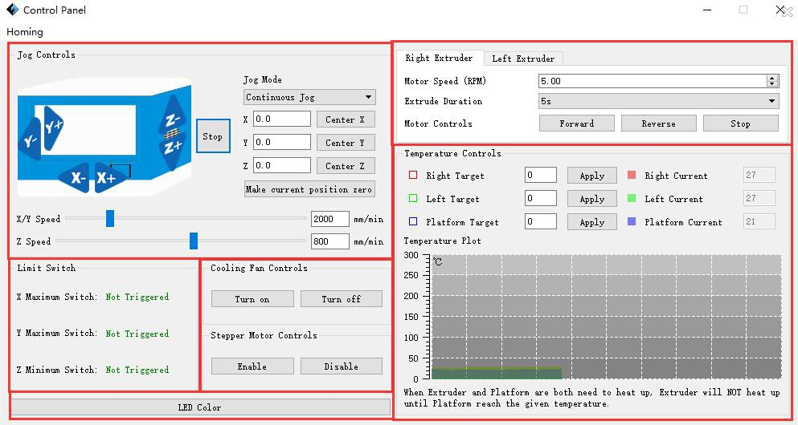
1
5
6
2
3
4

Jog Controls
- Jog Mode：Select the distance that extruder/build plate move a single time (that is, the distance extruder/build plate move upon your single click).
- Six blue arrow direction buttons: Control the move along X/Y/Z axis. X/Y axis button control extruder movement, Z axis button control build plate move. Click X-, extruder will move leftward a specified distance; Click X+, extruder will move a specified distance rightward. Click Y-, extruder will move forward a specified distance; Click Y-, extruder will move backward a specified distance. Click Z-, build plate will move upward a specified distance; Click Z-, build plate will move downward a specified distance. (Specified distance refers to the move distance you set in Jog Mode.
- Stop: Click the [Stop] button to abort the current movement.
- XYZ coordinate frame on the r ight side: Show the current position of extruder/build plate.
- Make Current Position Zero button: Set the current position of the
extruder/build plate as (0, 0, 0). (NOTE: X, Y, and Z boxes are for display purposes. Changing the value in the boxes will not affect anything.
- Center X/Y/Z button: Extruder and build platform will back to the zero (0, 0, 0)

you set last time.
- X/Y Speed and Z Speed: Set the move speed of extruder/ build platform.
- Limit Switch: In order to protect your Inventor, three limit switches are equipped to control the maximum position, and the three limit switches corresponding to X/Y/Z axis limit switch. It has two statuses:
- Not Triggered: If the extruder/build plate don’t move to its maximum, X/Y/Z axis limit switch is not triggered, and shows “Not Triggered”.
- Triggered: If the extruder/build plate moves to its maximum, X/Y/Z axis limit switch is triggered, and shows “Triggered”.
- Stepper Motor Controls: Allows users to control to stepper motor. Click [Enable], and lock the motor so it does not allow any movement; click [Disable], and unlock the motor to be controlled manually.
- LED Color: Allows users to change the LED color of Inventor.

- Extruder Controls: You can set the value of “Motor Speed (RPM)”, which can control the rotation speed of filament feeding wheel. The motor rotation time can be controlled via setting the value of “Extruder Duration”. Generally we suggest the users choose option of continuous time 60 seconds. The filament must be loaded in the extruder before motor starts. Therefore, do not start rotation operation until the extruder temperature reach the printing temperature of filament. For PLA filament, the extruder temperature should reach 220℃, after reaching the extruder temperature, click the [Forward]/[Reverse] rotation button to control filament load and filament unload. Furthermore, if you want to stop filament load and unload, you can click [Stop].
- Temperature Control: Input the temperature you want to get in the left frame, click [Apply], the printer will automatically heat the corresponding part, the right side shows the current actual temperature of corresponding part. After start heating, the

below curve of temperature form will start to change, different color correspond different parts’ temperatures

② Update Firmware
Every time when you start FlashPrint, it will automatically detect and download the up-to-date firmware. If any update is available, a dialog box will pop up for reminding the users to update.
Step 1: Click [Tools]--[Update firmware]. It needs to cut off connection before updating firmware. If software and printer are already in connection, it reminds you cutting off the connection, choose [Yes] and go on to the next step.
Step 2: Choose corresponding printer type and firmware version and click [OK] in the firmware updating box. After confirming the printer is in free state, the software will automatically update the firmware.
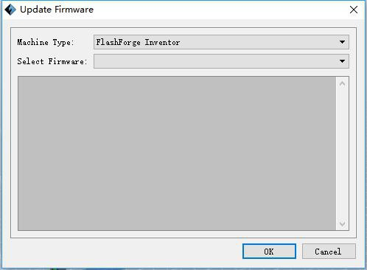

6-23
Step 3：Reboot you Inventor and wait for 4-5 seconds, then you can see the update process bar. When the update finishes, it will go back to the main interface.
Step 4：Tap [Tool]--[About] to check whether the updated version is right.

③ On Board Preferences
When the computer and printer are in connection, click [Tools]--[On Board Preferences], you can check the printer name.

④ Machine information
When the computer and printer are in connection state, click [Tools]--[Machine information], you can check the machine type, machine name and firmware etc.

6.2.15 Help Menus

① First Run Wizard
② Help Contents：Click [Help]--[Help Contents], you can read the help contents.
③ Check for Updates： Click [Help]--[Check for Update] to detect the available updates online.
④ About FlashPrint ：Click [Help]--[About FlashPrint], the software information box will pop up. The contents include the current software version and copyright information.

Chapter 7: Basic Printing

This chapter will provide a step-by-step guide on turning a 3D model into a physical reality. Before proceeding, it is recommended that you go over prior chapters on loading/unloading filament, leveling the build plate, and the functions and capabilities of FlashPrint.

There are two modes of printing: single-extrusion and dual-extrusion. With single extrusion, you can choose the print head to use for making the print. Dual extrusion is useful if you want to print dual colors or complex models that require supporting material.

There are three connection methods in order to print using the Inventor. All methods, which include USB cable, SD card, and Wi-Fi are covered in this chapter.

Single-Extrusion and Dual-Extrusion Print

    - Single-Extrusion Print
- Open FlashPrint by double-clicking on the icon.
- Click on [Load] and choose a .stl file from hard drive.
- The object will then be shown on the screen.
- Click on the object and then click on [Extruder], select [Use left extruder].
*Left extruder will be used for illustration purposes.
- Now the 3D model is ready to be created.

    - Dual-Extrusion Print

- Open FlashPrint by double-clicking on the icon.

- Click [Load] and choose an .stl file from hard drive.
- The object will then be shown on the screen.
- Click [Load] and choose another (or the same) file from hard drive.
- Click on the object and then click on [Extruder], select [Use left extruder].
NOTE: one object is turned to green, that indicates it will be print wit the left extruder.
- Now the 3D model is ready to be created.
Before introducing the connection methods, let me give you a brief introduction of Inventor’s interfaces.

 | Print
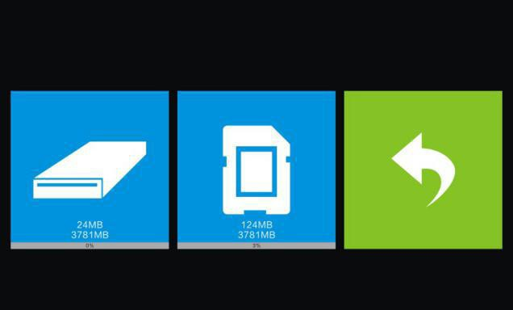 | Read the print file from The local memory card The SD card  Back

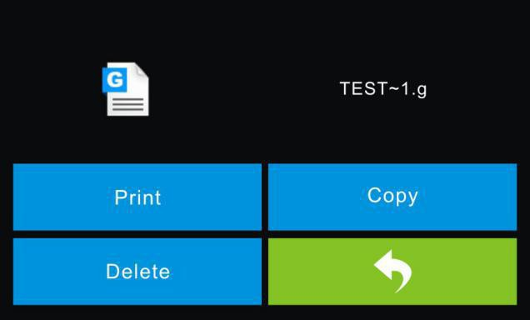 | Select the target print file among the list Print: To begin printing  Copy: To copy the files to the local memory card from the SD card.(No available [Copy] button for printing from local memory card )  Delete: To delete the print file Back
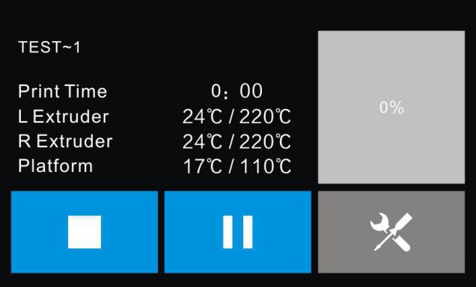 | Print interface  Abort: To abort the print job. Pause/Resume: To suspend or resume the print job.  Tools: To change filament and turn on/off camera.
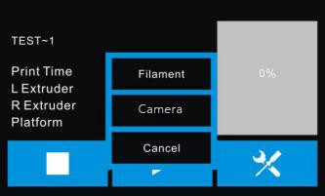 | Tools in print interface  Filament: To change filament during printing.  (Note: You need to suspend the operation first)  Camera: To turn on/off the camera Cancel: To end the tool orders and return to the print interface.
 | Preheat

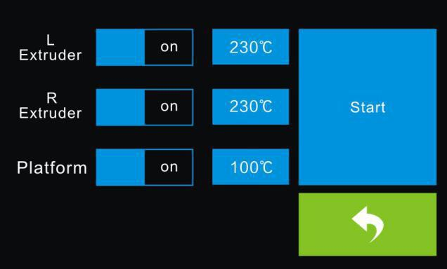 | Tap the [Preheat] button to enter the preheat interface. Tap the [Start] button to heat up to the setting temperature.  The default temperature is 230℃.  Tap the temperature display bar to set the temperature.
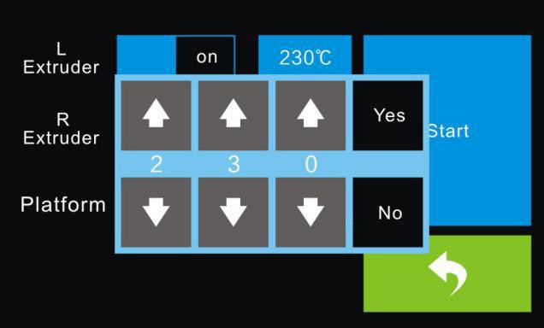 | To set the preheat temperature.  Tap [Yes] to save the setting while tap [No] to cancel the setting.
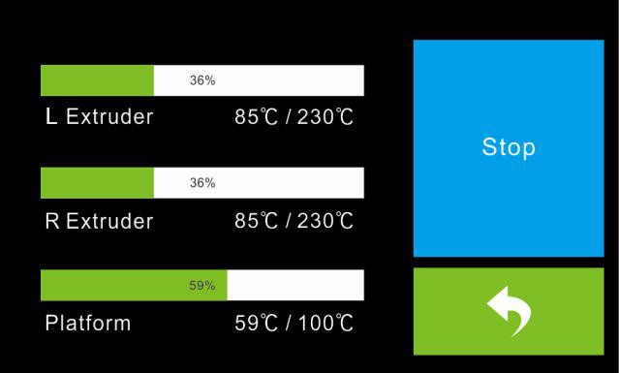 | The picture displays the preheat interface. It shows the actual temperature and the target temperature. Tap the [Stop] button to abort the preheat job.
 | Tool

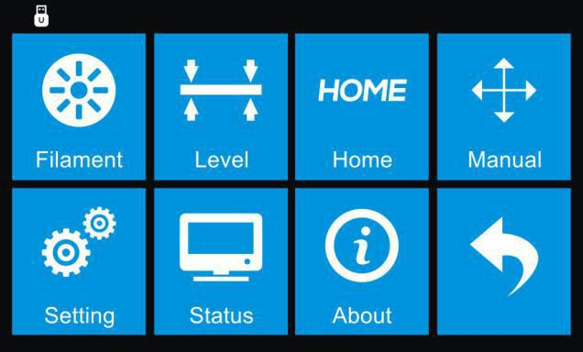 | Tap [Tool] to enter tool options. Filament: To load/unload the filament. Level: To adjust the build plate.  Home: To make the X, Y and Z axes back to the zero point.  Manual: To manually adjust the positions of X, Y and Z axes.  Setting: To implement relevant function setups.  Status: The check the real-time status of the printer.  About: Information about the printer.  Back
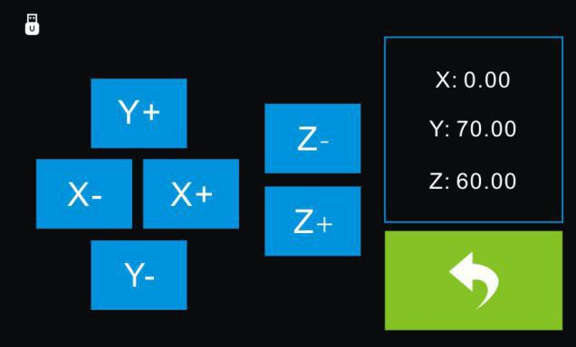 | Manual adjustment  Y+: The extruder moves to the zero point, that is, the back of the machine  Y-: The extruder moves to the direction opposite to the Y+.  X+: The extruder moves to the zero points, that is, to the right direction  X-: The extruder moves to the direction opposite to the X+.  Z+: The build plate elevates. Z-: The build plate descends. Back
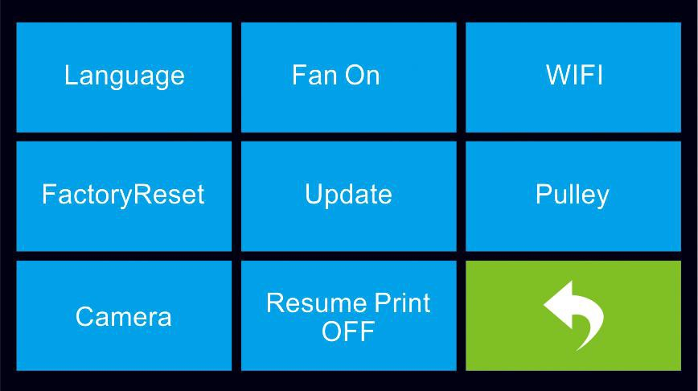 | Tap [Setting] to enter the setting interface  Language: To set the display language Fan On: To turn on/off the fan  WiFi: To turn on/off the WiFi  Factory Reset: Restore factory defaults Update: To update the firmware Pulley: To choose the pulley type Camera: To turn on/off the camera  Resume Print Off: To turn on/off resume print  Back

 | Language:  User can select corresponding language as required.
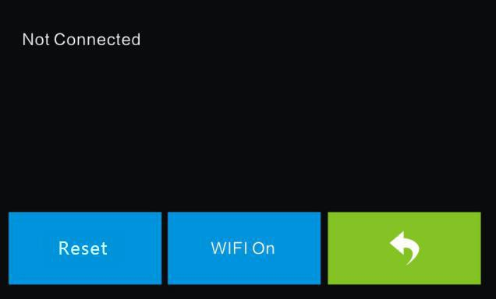 | WiFi:  Reset: To reset WiFi  WiFi On: Turn on the WiFi, release the WiFi hotspot and set the WiFi on computer  Back
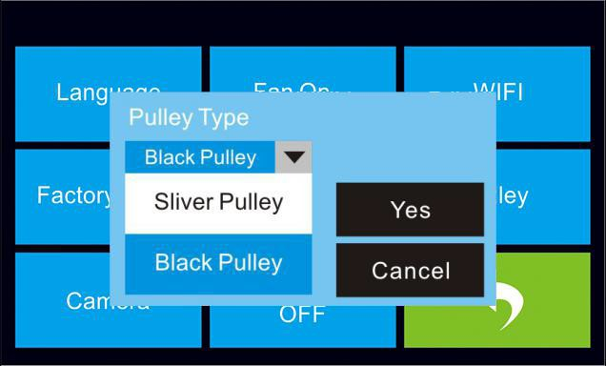 | Pulley:  Pulley Type: To select the equipped pulley type.  Yes: To confirm  Cancel: To cancel and back
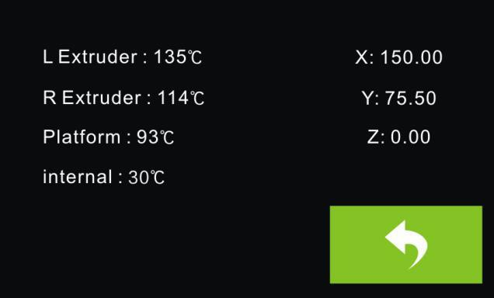 | Status:  It displays the real-time status of the extruder temperature, the platform temperature and the internal temperature.

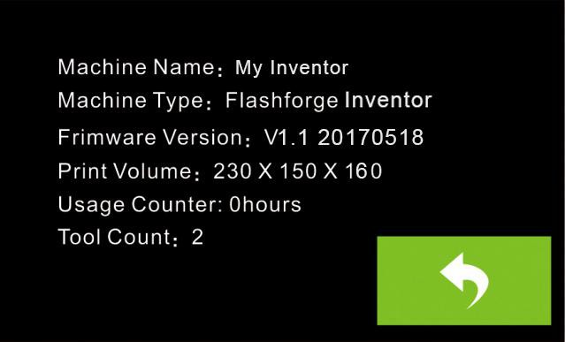 | About:  It displays the basic information about the device.

Methods of printing

Printing from USB
- Connect Inventor to the computer using the included USB 2.0 cable.
- Turn on the Inventor. Make sure the build plate is leveled and filament is loaded into the left extruder.
- Select [Print] from menu bar, then select [Connect].
- Click on [Rescan], then [Connect].
- Now the printer is connected with FlashPrint. A status box at the lower right corner will show the temperature of both extruders and the platform.
- Click [Print] icon, and a printing options screen will appear. Make sure that “PLA” is selected under Material Left. Advanced settings can be set under [More Options] icon. Check the box “Print When Slice Done” and click [OK].
- Save the file at any location, and the object will start slicing
- After the object is done slicing, it will automatically upload the gcode to the Inventor.
- After the gcode is done uploading, the printer will go into a preheat phase. The Inventor will begin printing once it has finished preheating.

Printing from SD Card
- Click [Print], and a printing options screen will show up.
- Make sure that the “Material Left” is selected as “PLA.” Advanced settings can be

set under [More Options] icon.
- Click [OK], and save the gcode file in the SD card.
- FlashPrint will begin slicing the 3D model.
- After the object is done slicing, take the SD card out from the computer. Insert it into the SD card slot on the Inventor.
- Turn on the Inventor. Make sure the build plate is leveled and filament is loaded on the left extruder.
- Tap [Print] and then tap the middle SD Card icon.
- A list of file(s) will show up, tap the file that you would like to print, then tap [Yes].
- The printer will now enter preheating phase and will start printing once it finishes preheating

Printing via Wi-Fi
- Turn on Inventor.
- Turn on Wi-Fi on the Inventor. Tap [Tool]-[Setting]-[WiFi]-[ WiFi ON].
4. A connection called“Inventor 1” can be found on the your computer available networks list. Connect your computer to this network.
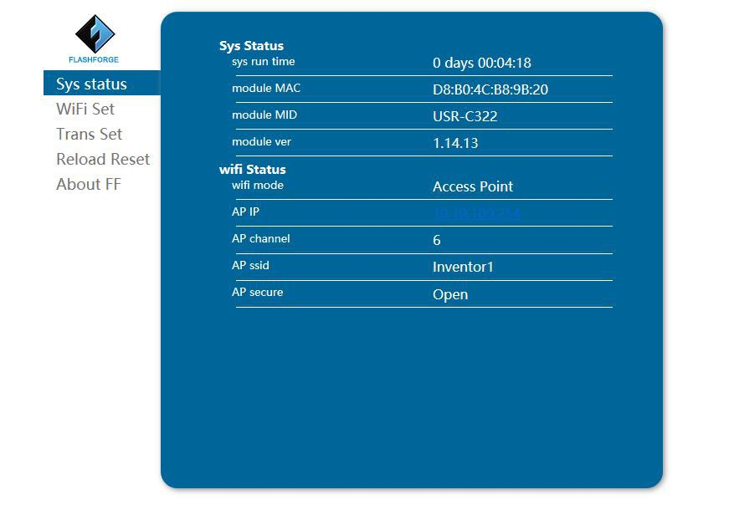
4. Open your Internet browser in your computer. Type in “10.10.100.254” and hit [Enter] on your keyboard. Enter the username and password to login. The default username and password are both “admin.” The control panel will appear after a successful login.

Inventor User Guide | www.FlashForge.com 60

6-20

5. Click on [WiFi Set] and choose“AP mode” or “STA mode”in WiFi Model Select and save it. Click [Restart] to take effect.

7. AP Mode：You can set the network name(Inventor1) and password of the hotspot in AP mode. If you don’t want to set the password, select “None”. Then save and restart it. Connect your PC to the network named “Inventor 1”. Open FlashPrint,
click[Print]--[Connect Machine]. Under “Connection Mode”, select Wi-Fi, and enter the “IP Address” as shown on Inventor touch screen. Then, click [Connect].

STA Mode: Select a working network, enter the corresponding name and password and save in STA mode. Then save and restart it. Restart your Inventor and open wifi.

6-22

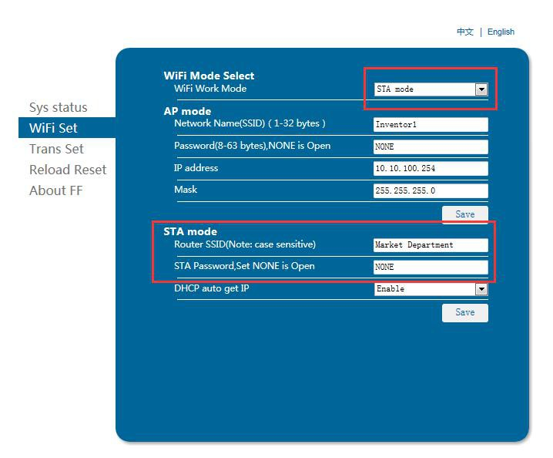
Turn on the Inventor again and connect your computer to the network . Open FlashPrint, click[Print]--[Connect Machine]. Under “Connection Mode”, select Wi-Fi, and enter the “IP Address” as shown on Inventor touch screen. Then, click [Connect].If successfully connected, you will see the following red mark.

Note: If you want to swich STA mode to AP mode, tap [Reset] in wifi fucntion of the Inventor.

Disconnect Inventor
Click [Print]--[Disconnect] to disconnect your PC and Inventor. NOTE: Printing from SD card is unavailable when WiFi is ON.

Printing with Support
If the 3D model has excessive over-hang, then support will be needed. In the Slice options screen, select from “Supports” the left or right extruder. Click [OK] to begin slicing.

Camera Setting

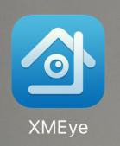
Before setting we need to download and install a video monitor APP named XMEYE on the phone. Search XMEye app in App store, and download the app. As shown in figure 7-4.

Direct Login
7-4

- Tap [Tool]-[Setting]-[Camera]，it will represent following interface(7-5), then tap [On] to turn on camera WiFi signal, you can see “Turned on” at the top left corner.
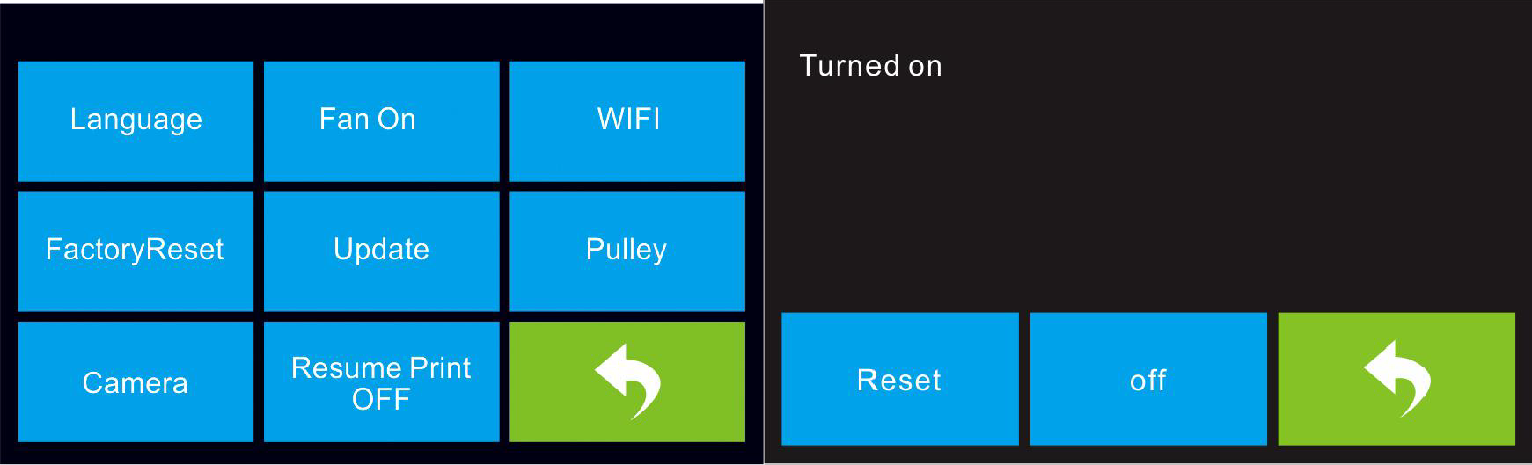

7-5

- Scan camera’s WiFi hotspot in WiFi hotspot interface of mobile phone, as shown in figure 7-6. Each camera’s hotspot is named with the prefix xmjp, while the back names are different. If the hotspot can not be found, please tap [Reset] on printer
touch screen, and scan again. Connect the right WiFi and the password is 1234567890
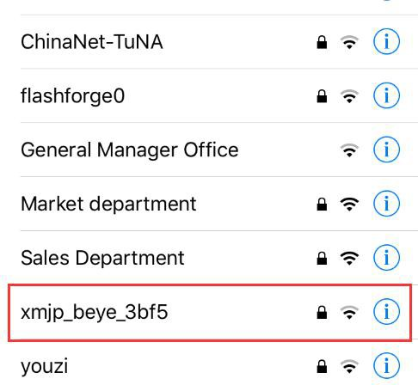

7-6

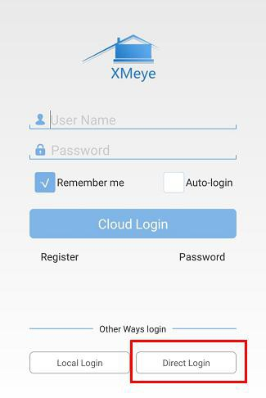
- Open the XMEye app after your phone successfully connected with the WiFi signal, tap [Direct Login] to review the video. Now the camera is directly connected to the phone, the video will interrupt once over the available cover distance.

7-7

Local Login

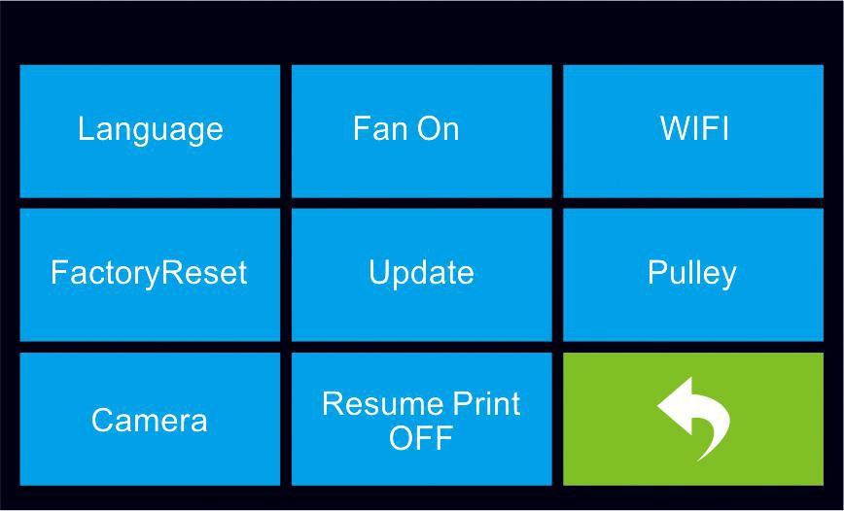
- Tap [Tool]-[Setting]-[Camera] ， it will represent follow interface(7-8), then tap [On] to turn on camera WiFi signal, you can see “Turned on” at the top left corner.
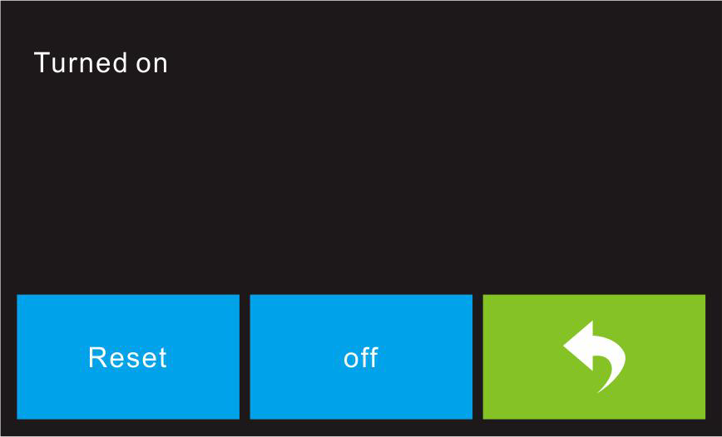
7-8
- Connect your mobile phone to an available WiFi, then open XMEye app select local login, tap [+] which is on the top right to add device.
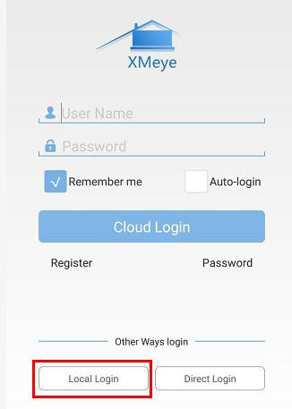
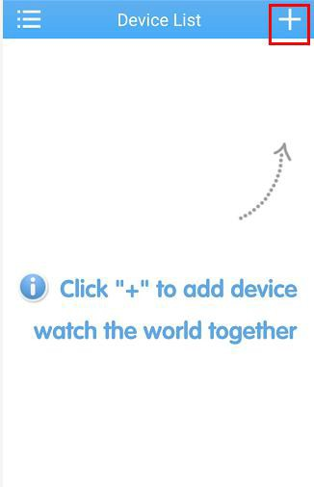

7-9

- Select [WiFi Config], enter the password of the the WiFi, check the following two dialogs that you have done and tap [Complete all of the above operation].

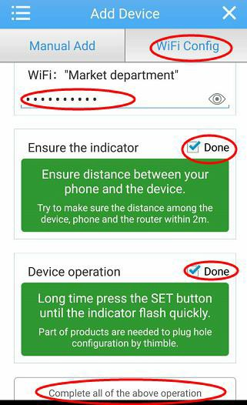
7-10

- Tap [Reset] on the printer touch screen, tap [Yes] on the top-up box of the phone.

Attention: Android users don’t have top-up box.
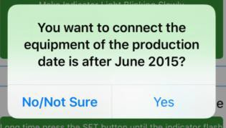
7-11

- The app starts to scan the available camera, if a green point comes up it means configured correctly, otherwise, you need to start from the first step. Tap the green point coming up the following figure 7-12, and then tap [OK].



7-12

- You can review the new device in device list, tap to watch the video.
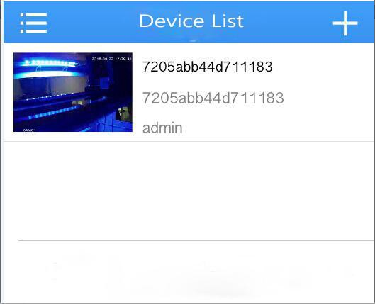
7-13

- After add the device the camera WiFi hotspot signal xmjp-beye-xxxx will disappear. Now you have connected to internet. No matter where you are, as long as access to the Internet, you can watch or transfer the video. It is recommended to connect WiFi before watching.

Resume Print

We added resume print function in FlashForge Inventor. Resume printing the

unfinished model when open the printer in blackout situation, operation as follow.
- Turn on the resume print function, it shows [Resume Print OFF] which means this function has been turned on.

7-14
- Restart the printer after suddenly loses power, it will pop-up the following box, tap [Yes], printer will continue to print the unfinished model.
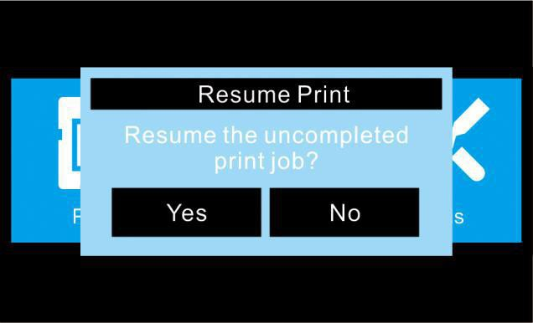

7-15

Chapter 8: Supports and Service
FlashForge team is on standby and ready to help you overcome any challenges you may have with your Inventor. If the issues or questions are not covered in this User Guide, you can seek for solutions on our office website or contact us via telephone.

There are solutions and instructions to common issues that can be found in our
knowledge base. Have a look first as most basic questions are answered there. http://www.FlashForge.com

The FlashForge support team can be reached by e-mail or phone between the working hours of 8:00 a.m. to 5:00 p.m. PST Monday through Saturday. In case you contact us during off-duty time, your inquiry will be answered the following business day.

Note: Because of changing different filament the exturder maybe blockaded. It’s not owing to quality issue, and outside the scope of 400 hours life. If users encounter this problem, please contact our after-sale department and finish cleaning work according to their instruction.

Email：support@ff3dp.com flashforge@flashforge.zohodesk.com support@flashforge.zohodesk.com

ADD：No. 518, Xianyuan Road, J inhua, Zhejiang

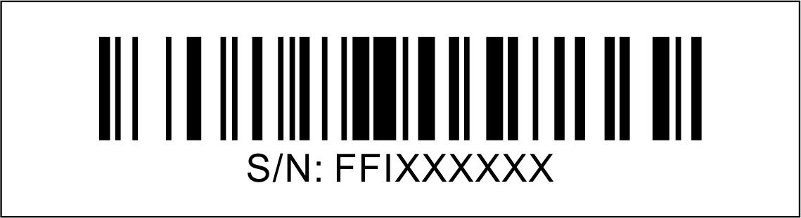
*When contacting support, please have your serial number ready. The serial number is a bar code on the back of your Inventor

